**VISVESVARAYA TECHNOLOGICAL UNIVERSITY**

**“JnanaSangama”, Belgaum -590014, Karnataka.**



**LAB REPORT**

**on**

**COMPUTER NETWORKS**

***Submitted by***

**RUTU SHRIKAR DESAI (1BM21CS173)**

***in partial fulfillment for the award of the degree of***

**BACHELOR OF ENGINEERING**

***in***

**COMPUTER SCIENCE AND ENGINEERING**



**B.M.S. COLLEGE OF ENGINEERING**

**(Autonomous Institution under VTU)**

**BENGALURU-560019**

**June-2023 to September-2023**

**B. M. S. College of Engineering,**

**Bull Temple Road, Bangalore 560019**

(Affiliated To Visvesvaraya Technological University, Belgaum)

**Department of Computer Science and Engineering**



**CERTIFICATE**

This is to certify that the Lab work entitled “**Computer Networks**” carried out by

**RUTU SHRIKAR DESAI (1BM21CS173),** who is bonafide student of **B.M.S. College of Engineering.** It is in partial fulfillment for the award of **Bachelor of Engineering in Computer Science and Engineering** of the Visvesvaraya Technological University, Belgaum during the academic semester June-2023 to September-2023. The Lab report has been approved as it satisfies the academic requirements in respect of a **Computer Networks (22CS4PCCON)** work prescribed for the said degree.

Name of the Lab-In charge:               Dr. Jyothi S Nayak

Lohith J J

Assistant Professor Professor and Head

Department of CSE Department of CSE

BMSCE, Bengaluru BMSCE, Bengaluru

**Index Sheet**

|  |  |  |
| --- | --- | --- |
| **Lab Program No.** | **Program Details** | **Page No.** |
|  | **CYCLE 1** |  |
| 1 | Create a topology and simulate sending a simple PDU from source to destination using hub and switch as connecting devices and demonstrate ping message. | 4 |
| 2 | Configure IP address to routers in packet tracer. Explore the following messages: ping responses, destination unreachable, request timed out, reply | 7 |
| 3 | Default routing and Static Routing | 13 |
| 4 | DHCP within LAN and outside LAN | 18 |
| 5 | Configure RIP routing Protocol in Routers | 23 |
| 6 | Configure OSPF routing protocol | 27 |
| 7 | Demonstrate the TTL/ Life of a Packet | 32 |
| 8 | Configure Web Server, DNS within a LAN. | 35 |
| 9 | To construct simple LAN and understand the concept  and operation of Address Resolution Protocol (ARP) | 38 |
| 10 | To understand the operation of TELNET by accessing the router in server room from a PC in IT office. | 41 |
| 11 | To construct a VLAN and make the PC’s communicate among a VLAN | 44 |
| 12 | To construct a WLAN and make the nodes communicate wirelessly | 48 |
|  | **CYCLE 2** |  |
| 13 | Write a program for error detecting code using CRC-  CCITT (16-bits). | 52 |
| 14 | Write a program for congestion control using Leaky bucket algorithm. | 56 |
| 15 | Using TCP/IP sockets, write a client-server program to  make client sending the file name and the server to send  back the contents of the requested file if present. | 59 |
| 16 | Using UDP sockets, write a client-server program to  make client sending the file name and the server to send  back the contents of the requested file if present. | 63 |

**Course Outcome**

|  |  |
| --- | --- |
| CO1 | Apply the fundamental concepts of communication in networking. |
| CO2 | Analyze the various protocols, techniques in TCP/IP network architecture |
| CO3 | Develop programs that demonstrate the functionalities of physical, Data Link, Network,Transport or Application layer |

**CYCLE 1**

**PROGRAM -1**

**Question: Create a topology and simulate sending a simple PDU from source to destination using hub and switch as connecting devices and demonstrate ping message.**

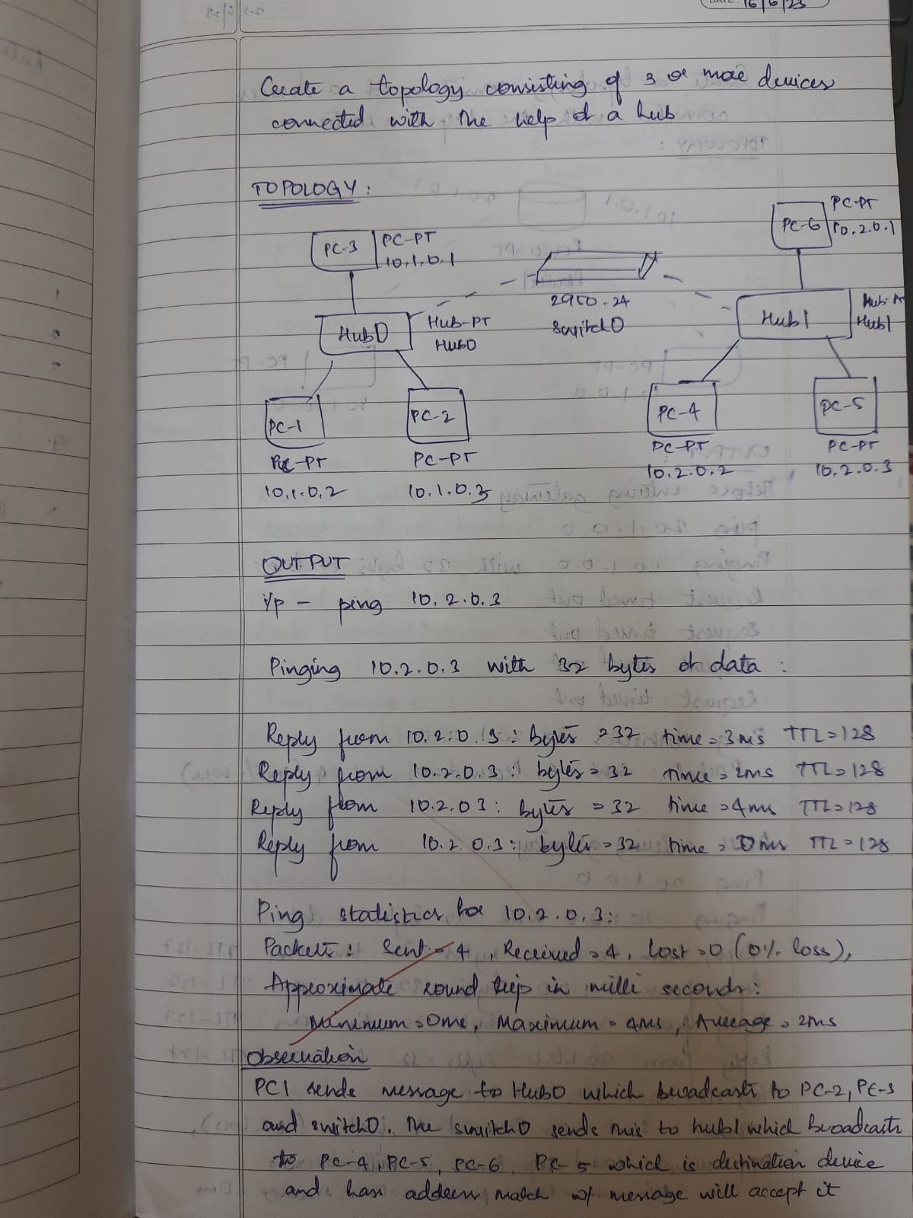

**Topology**

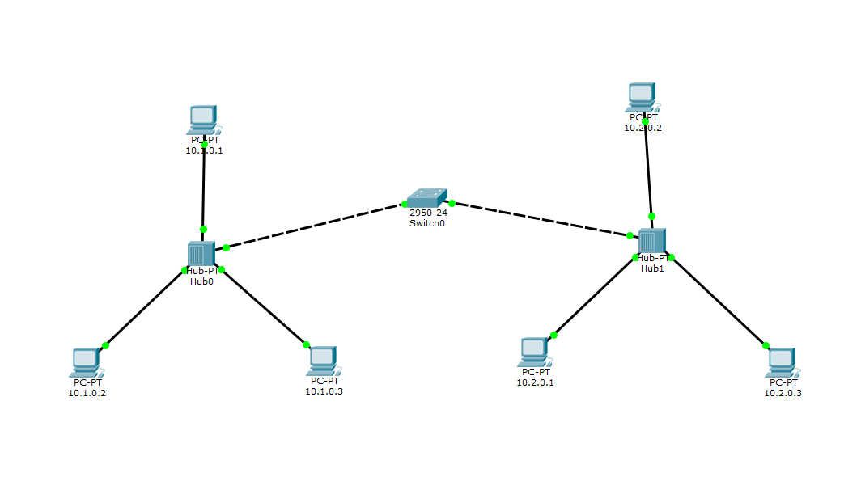**Output**

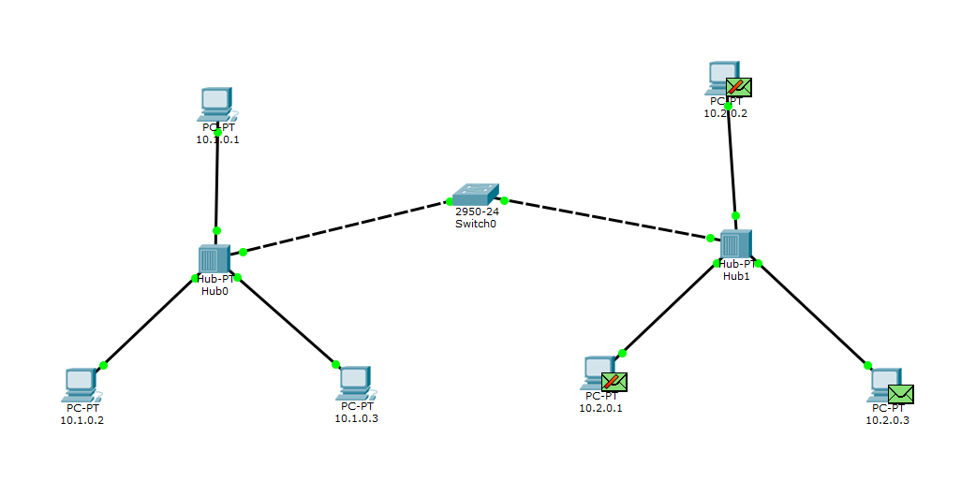

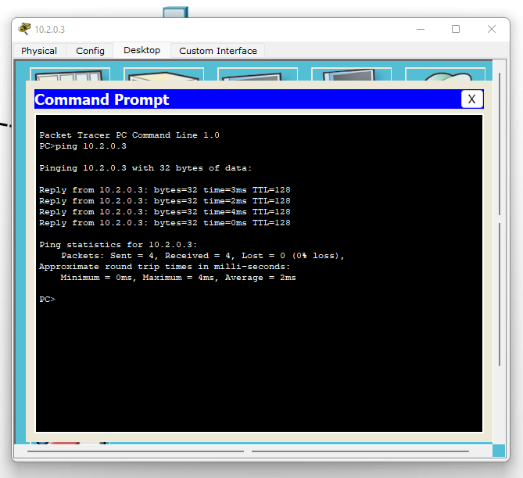

**PROGRAM -2**

Question: **Configure IP address to routers in packet tracer. Explore the following messages: ping responses, destination unreachable, request timed out, reply**

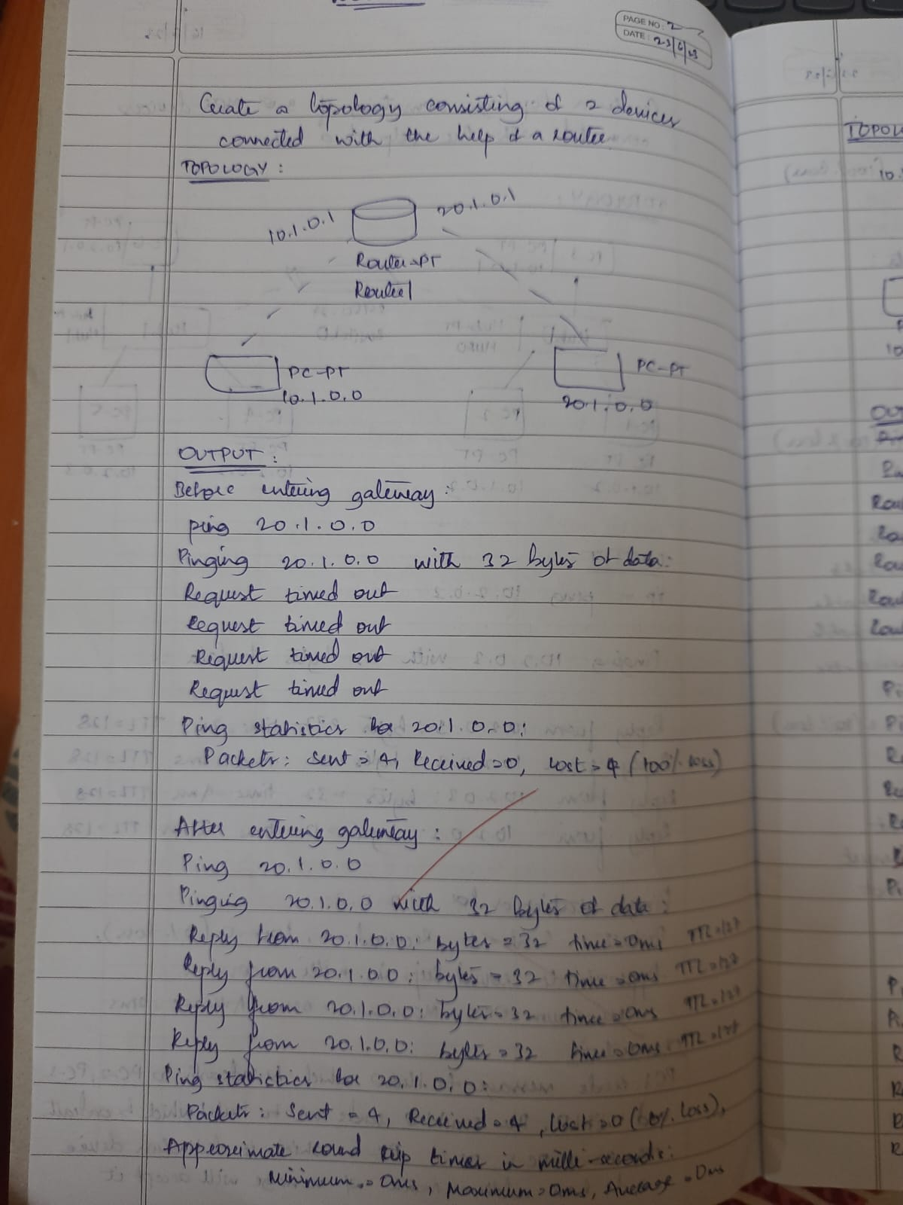

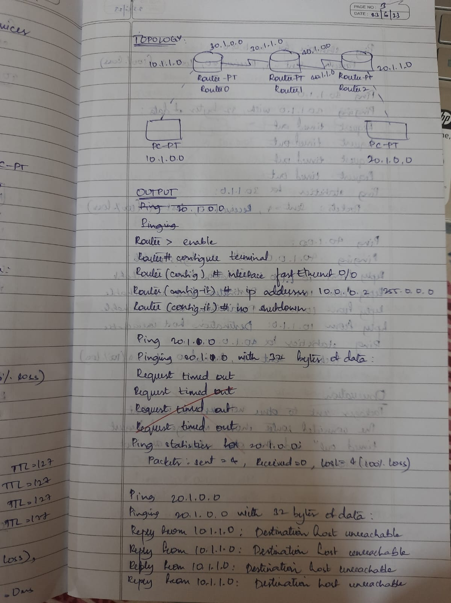

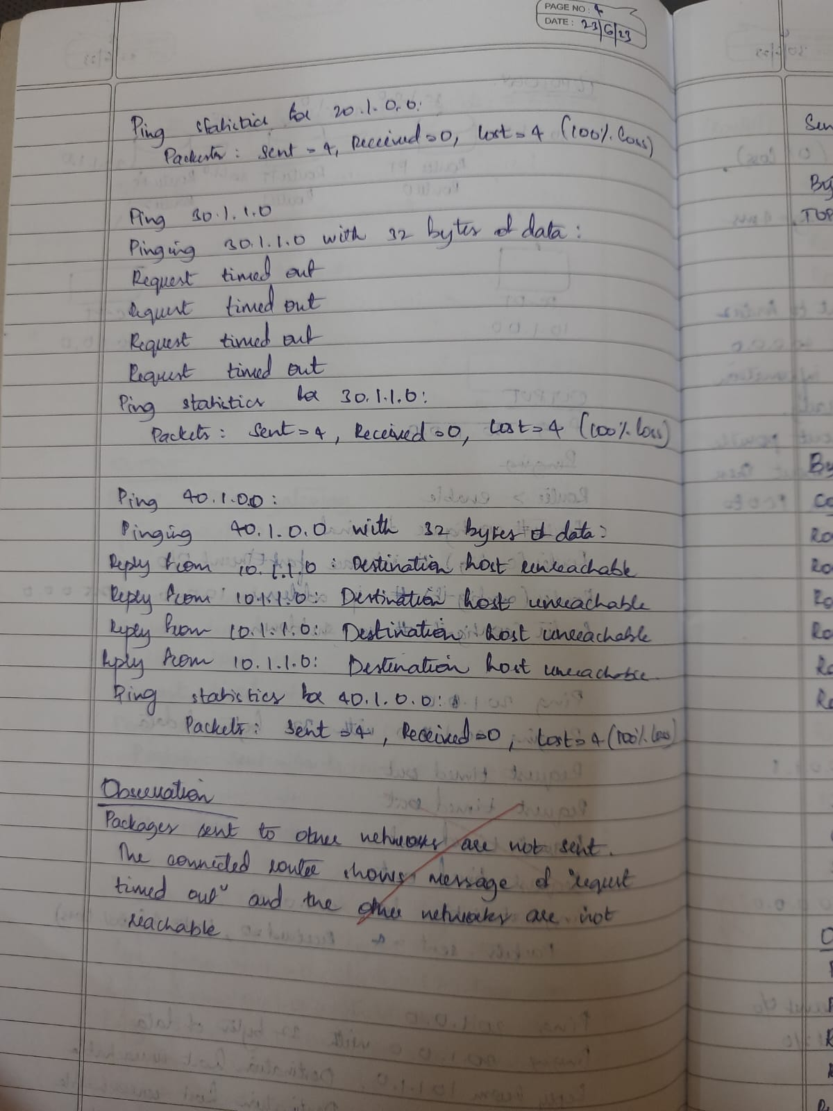

**TOPOLOGY**

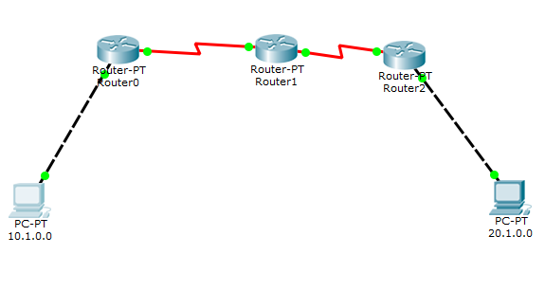

**OUTPUT**

**Before entering gateway-**

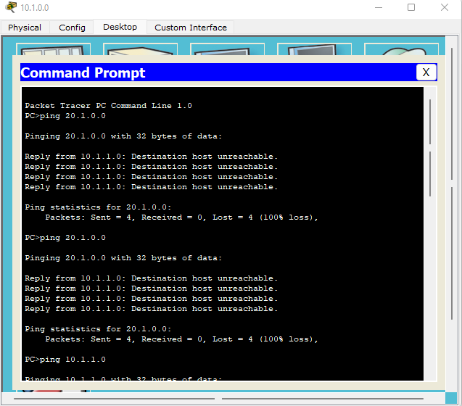

**After entering gateway-**

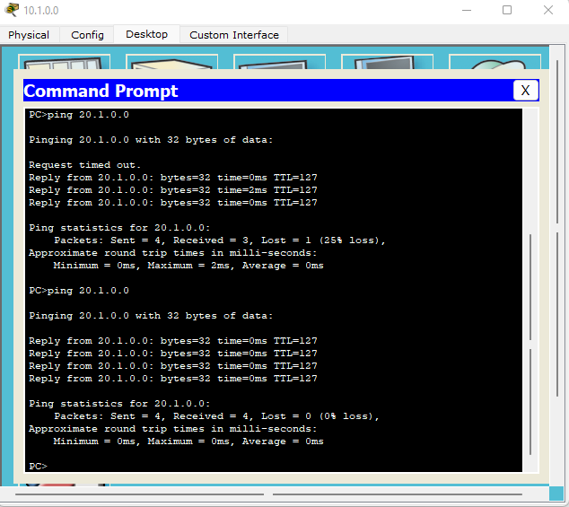

**PROGRAM -3**

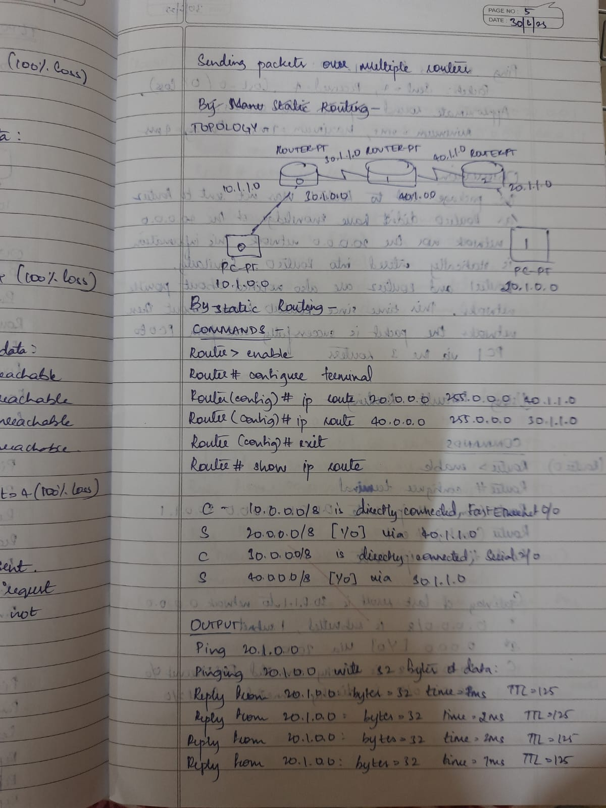**Configure default route, static route to the Router**

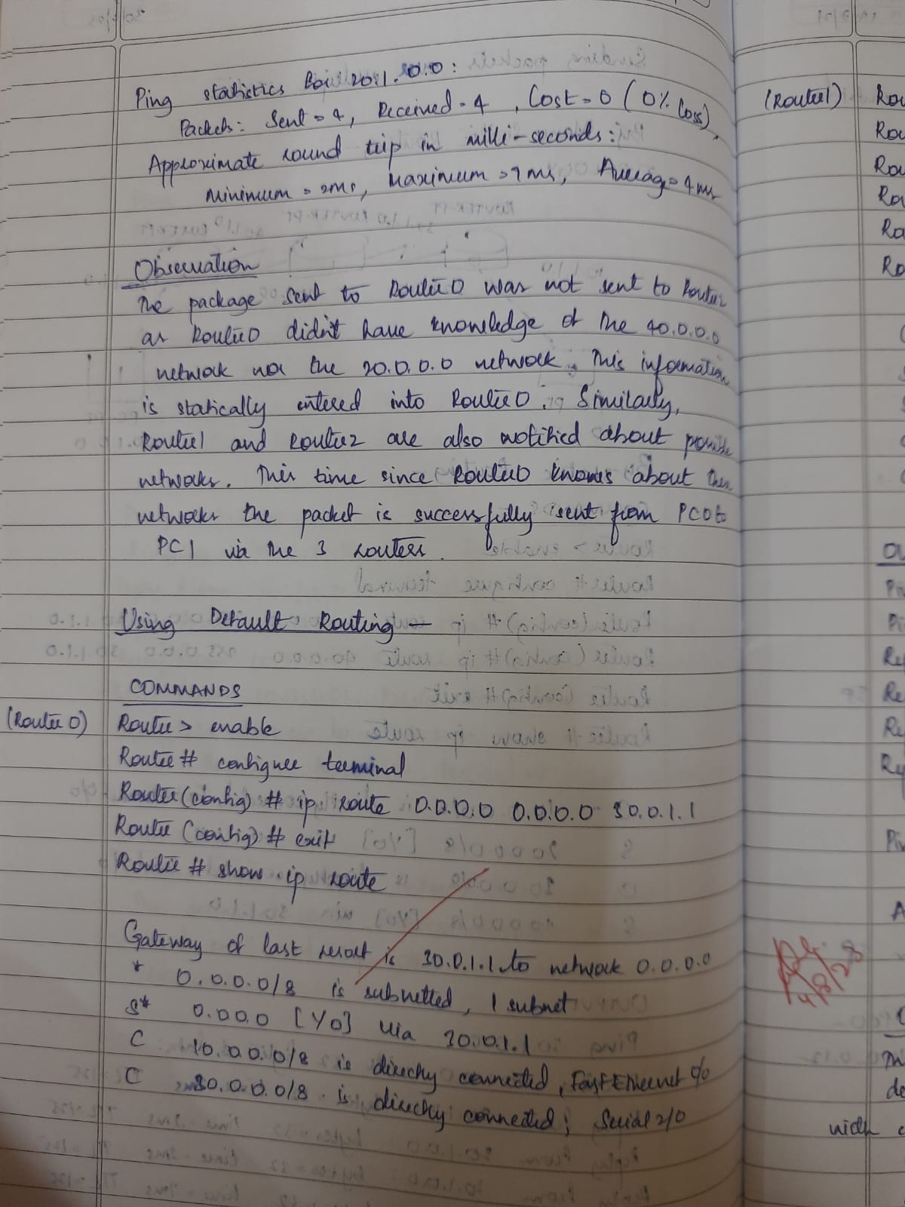

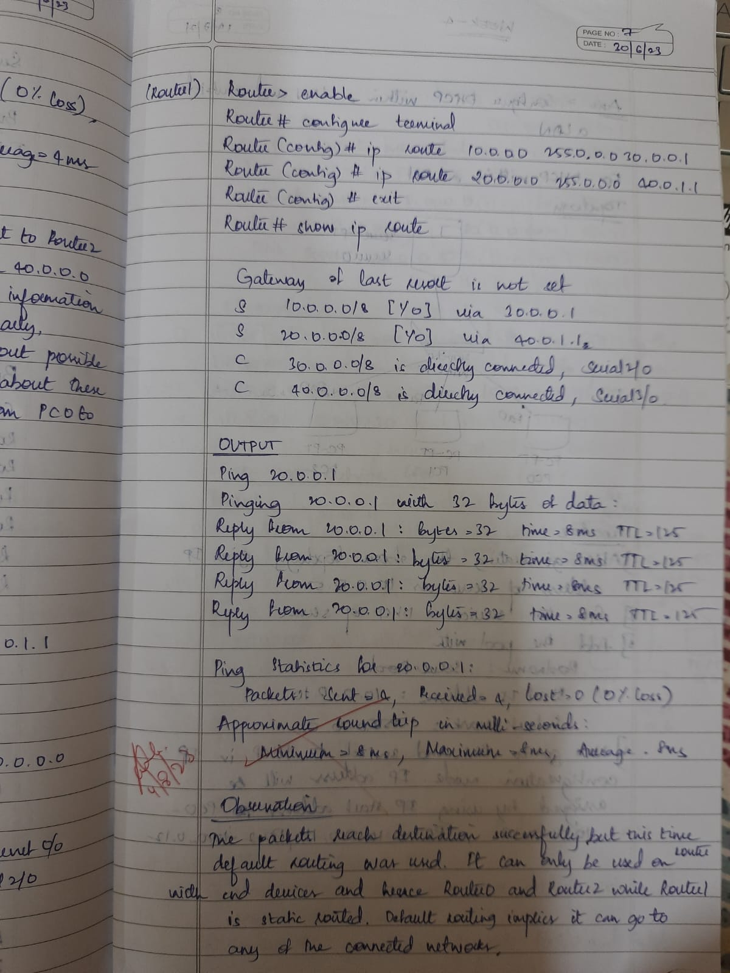

**TOPOLOGY**

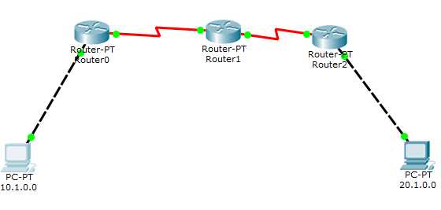

**COMMANDS**

**Static routing-**

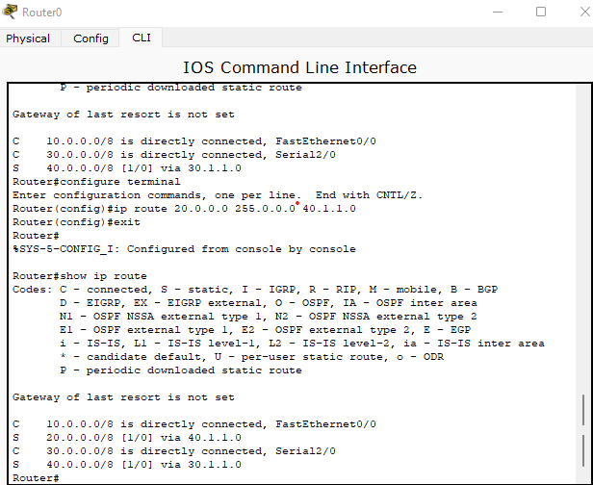

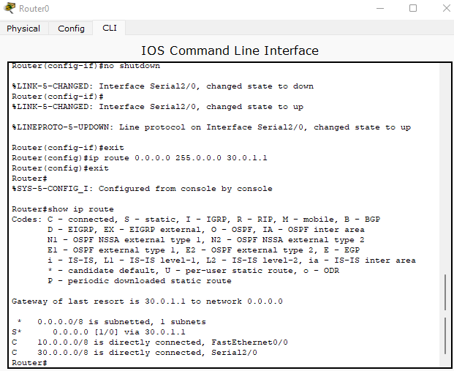**Default routing-**

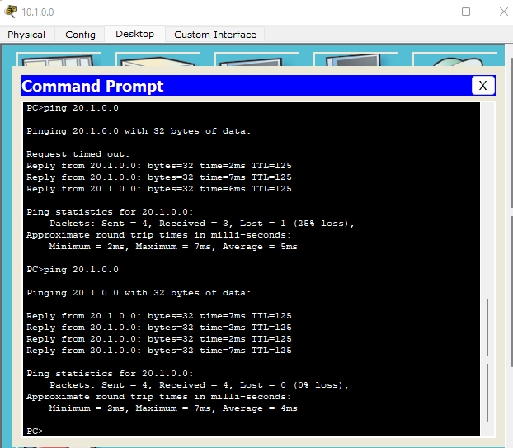**OUTPUT**

**PROGRAM -4**

**Configure DHCP within a LAN and outside LAN**

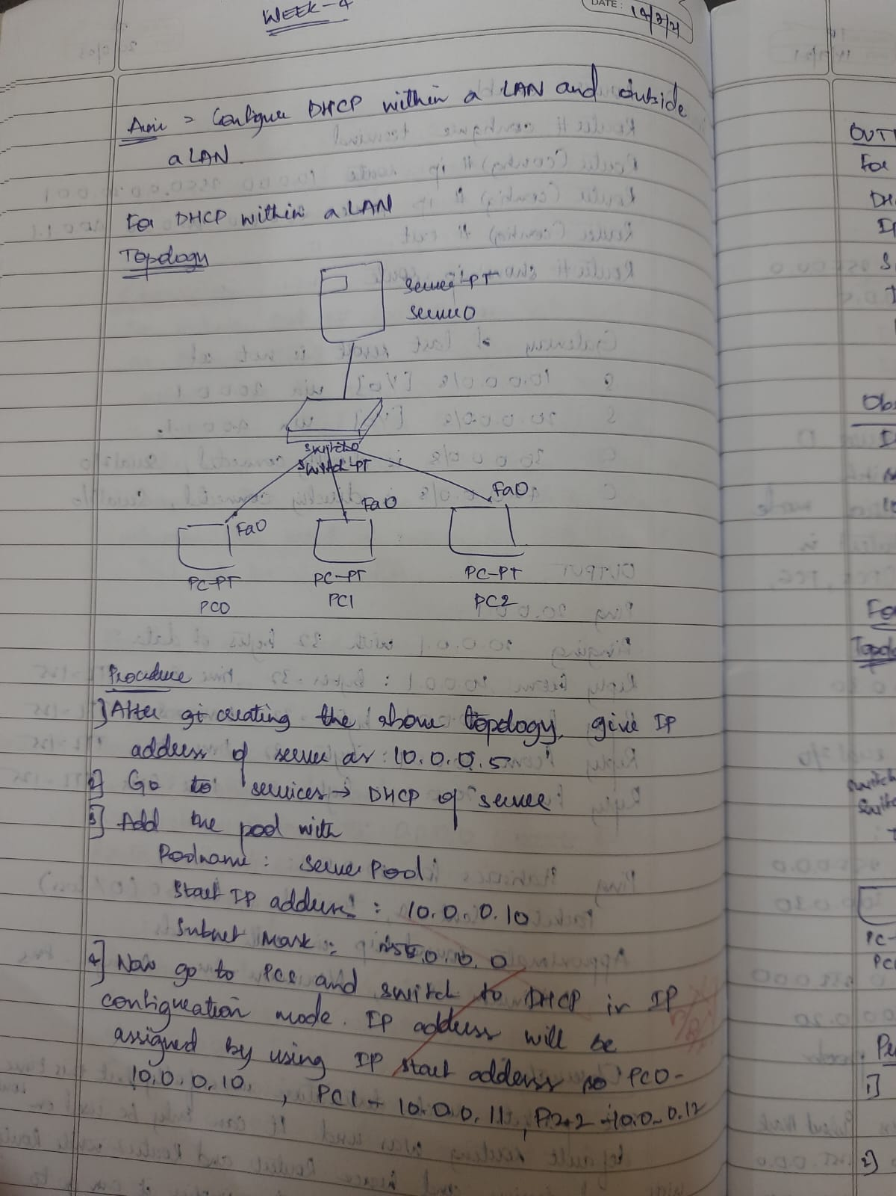

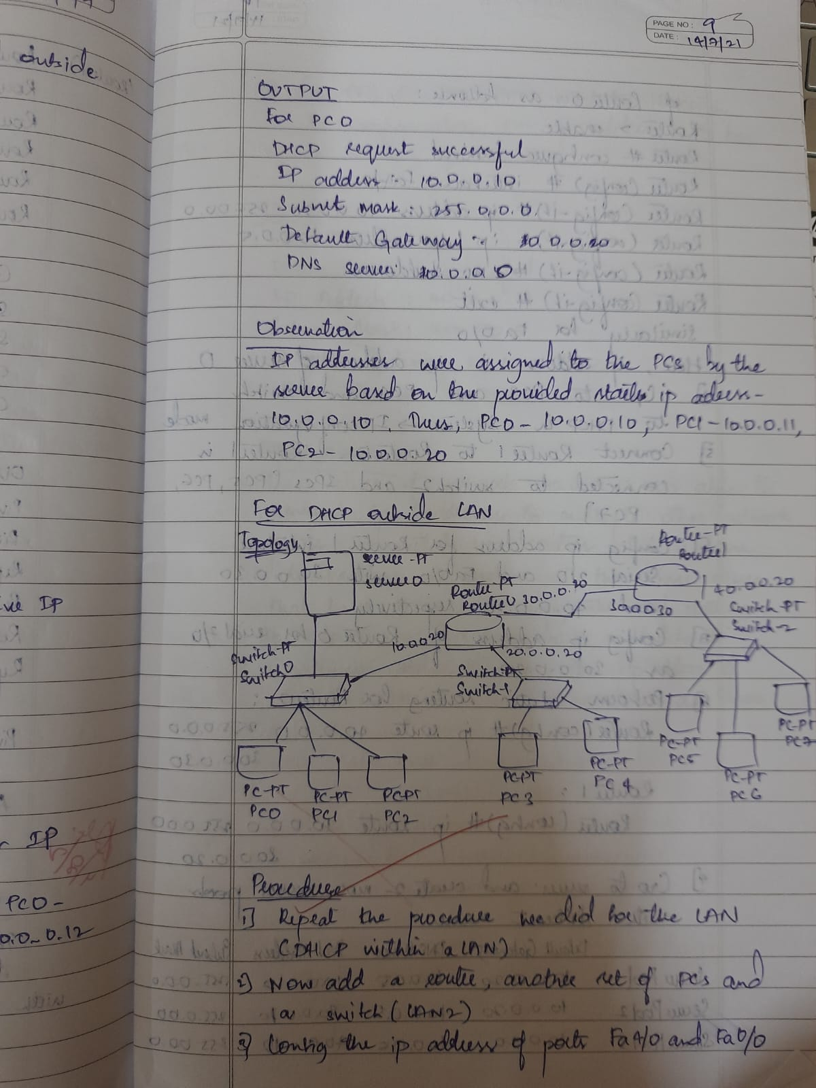

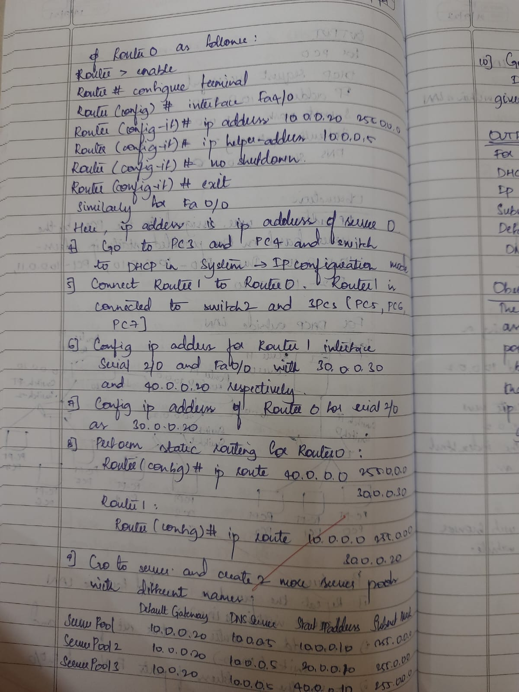

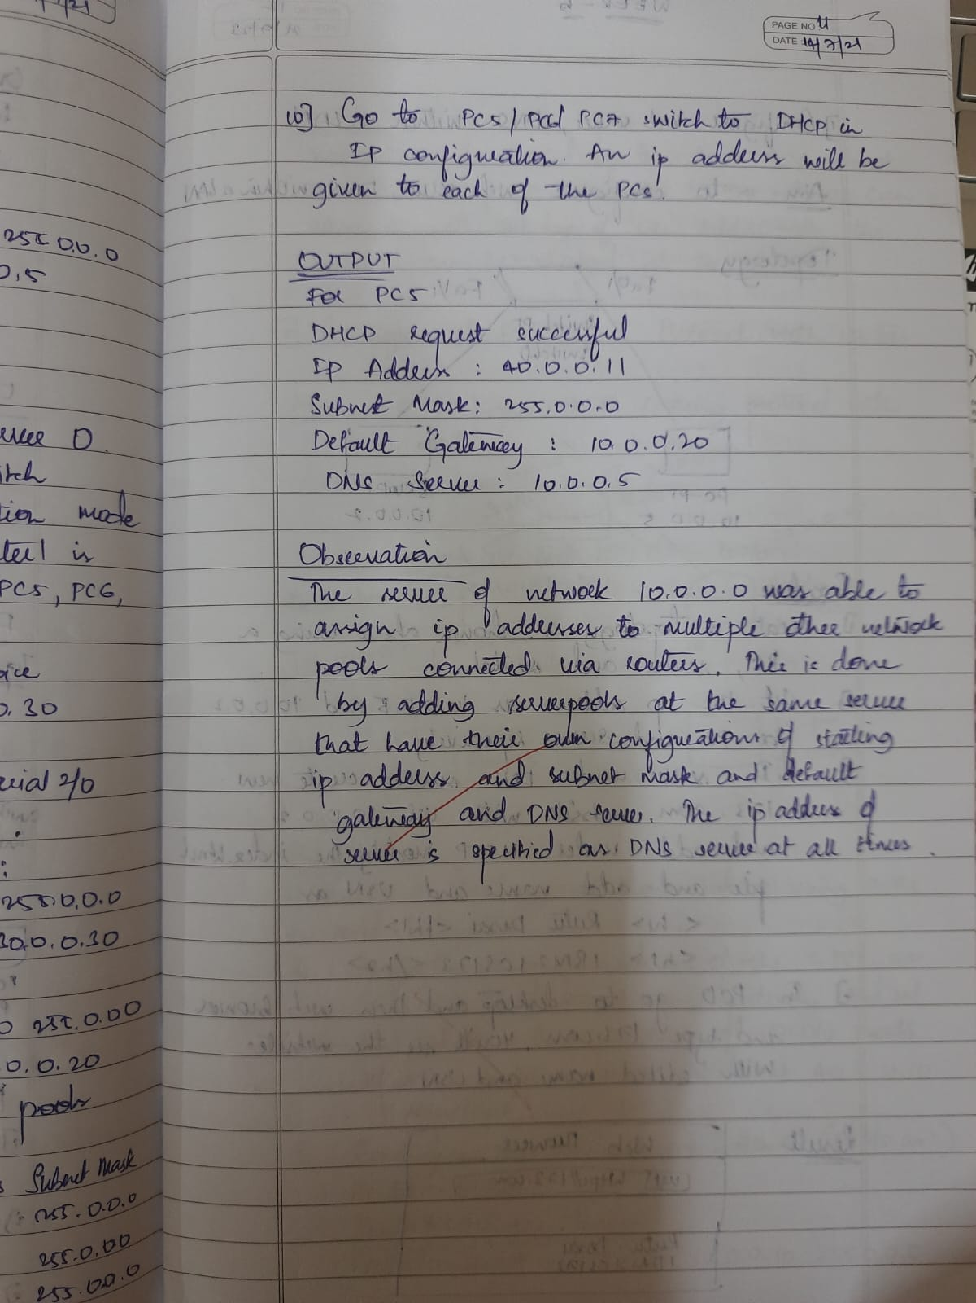

**TOPOLOGY**

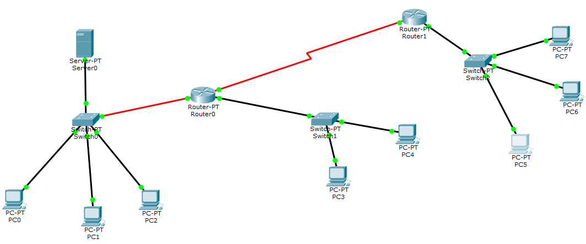

**CONFIGURATION-**

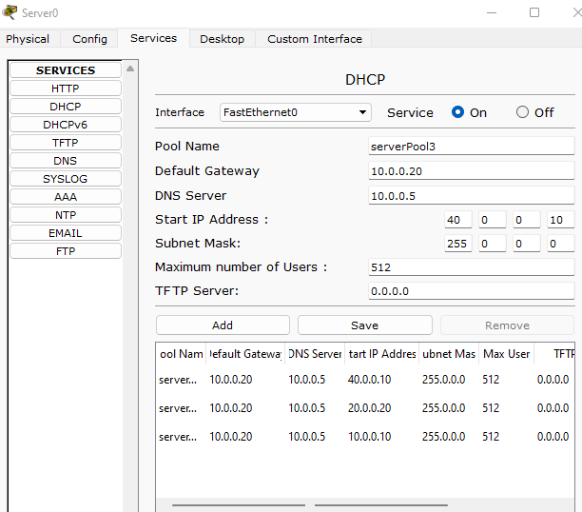

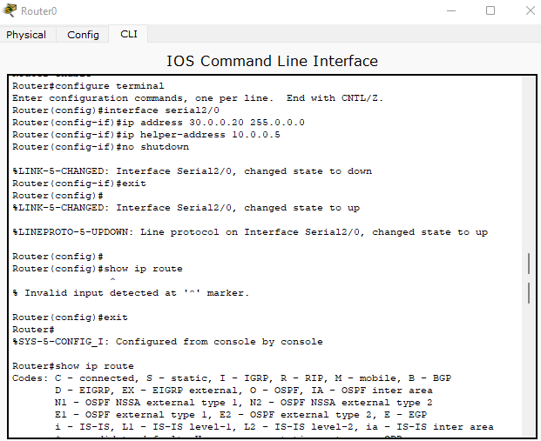

**OUTPUT**

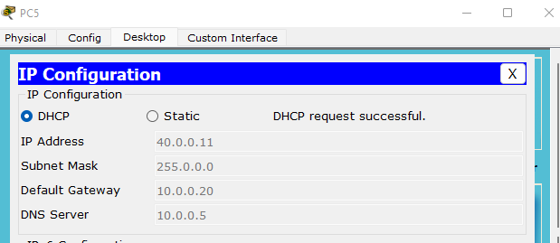

**PROGRAM -5**

Configure RIP routing Protocol in Routers

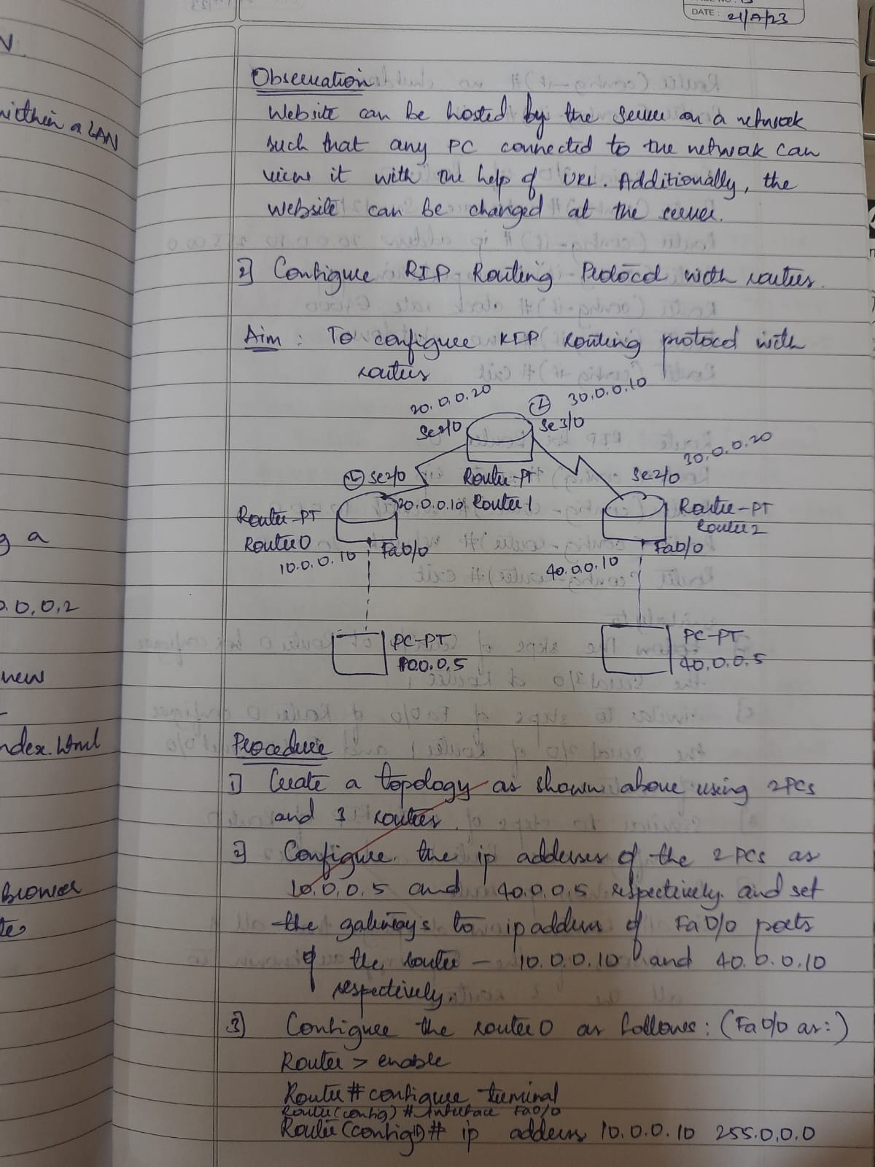

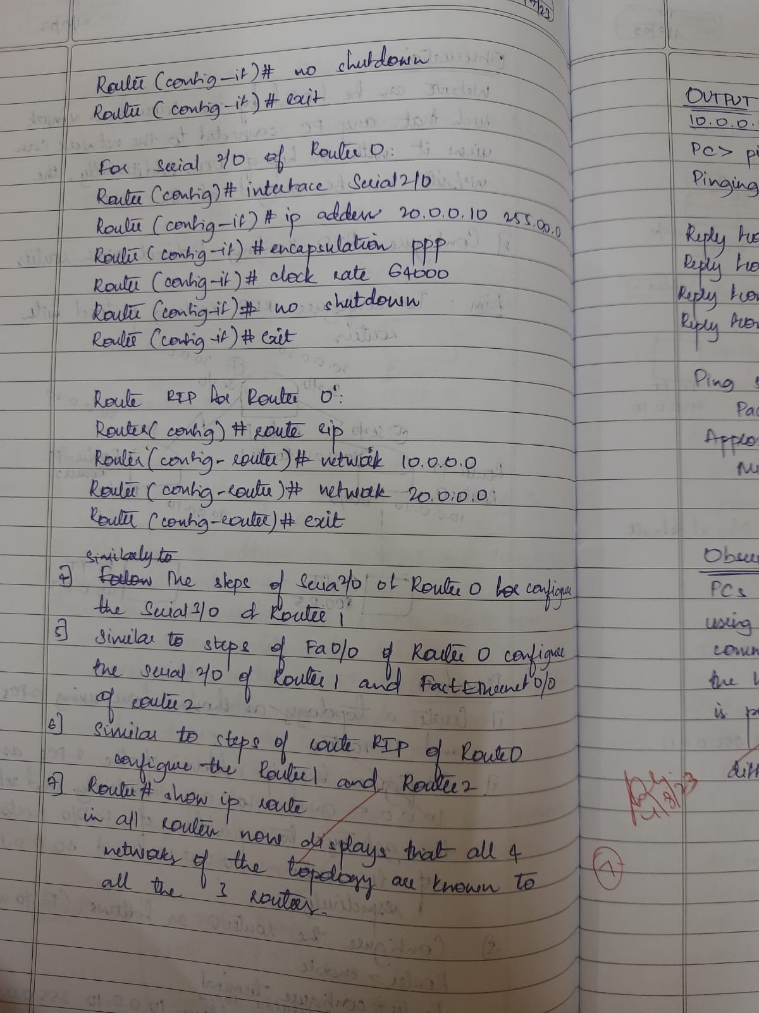

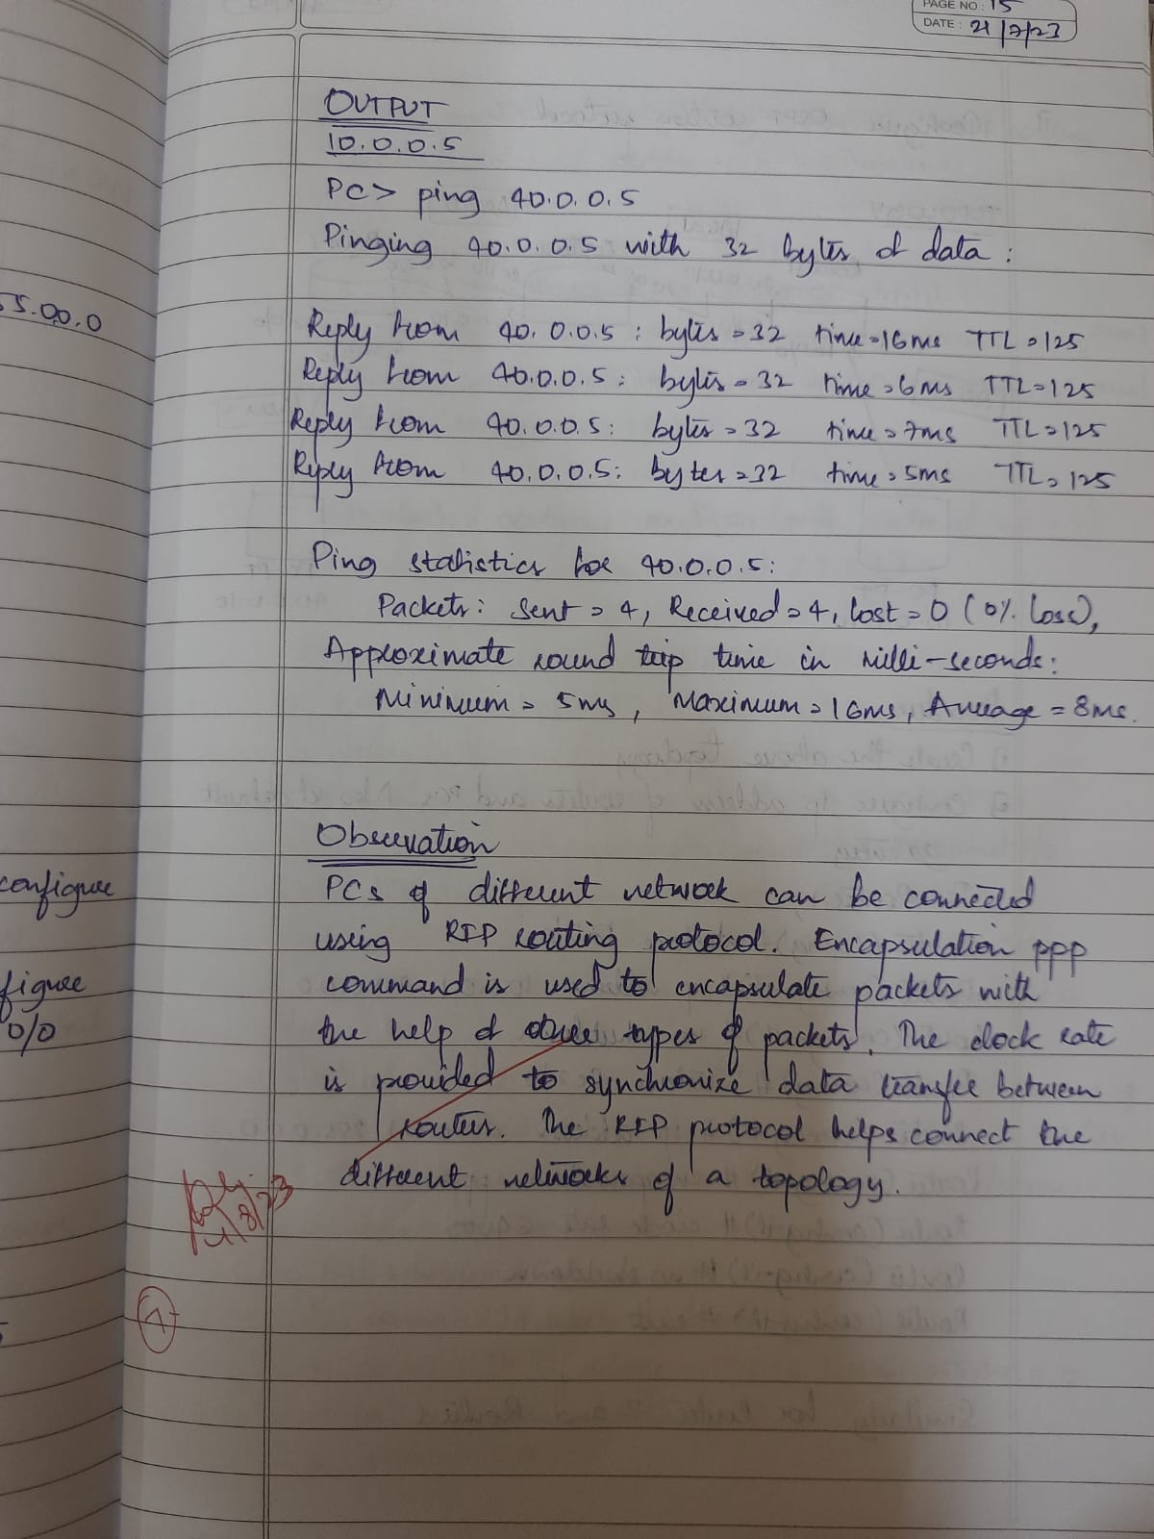

**TOPOLOGY-**

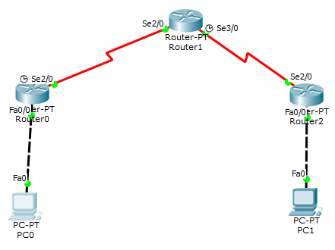

**CONFIGURATION**

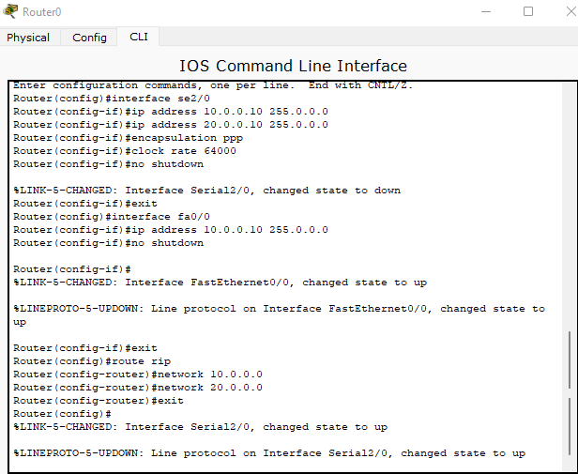

**OUTPUT**

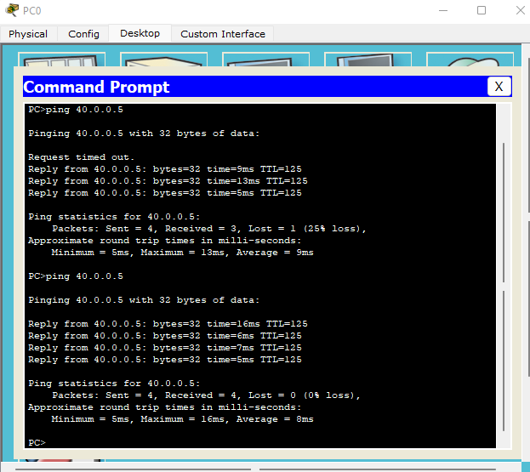

**PROGRAM -6**

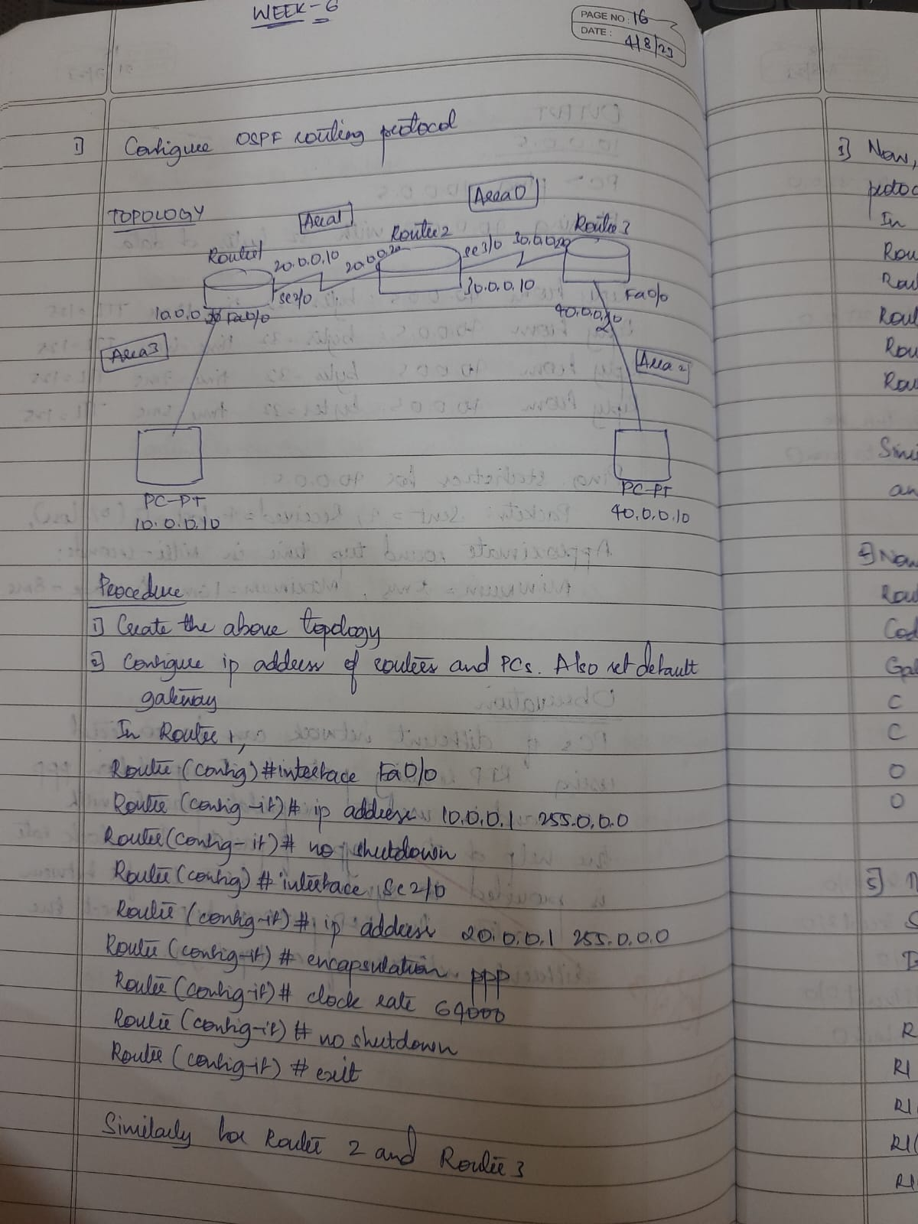**Configure OSPF routing protocol**

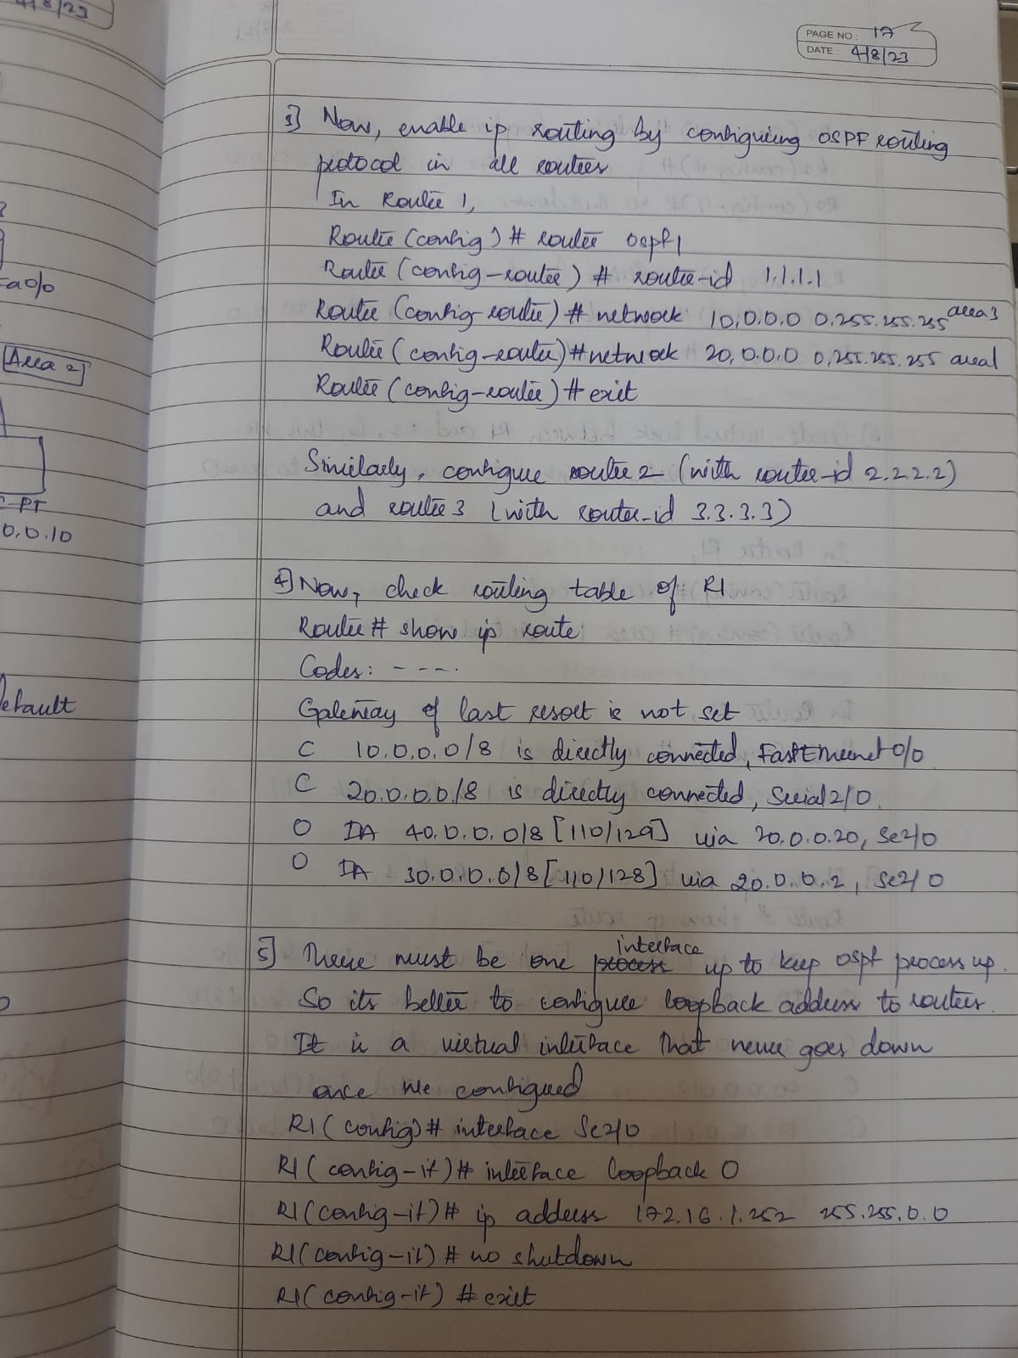

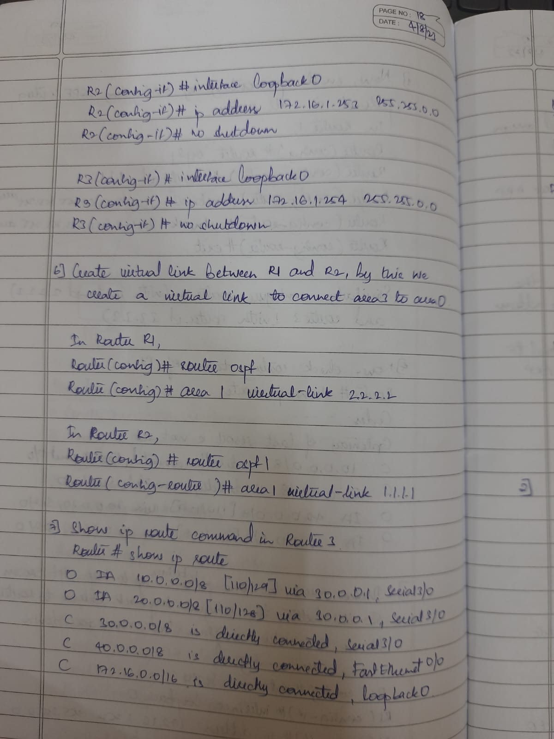

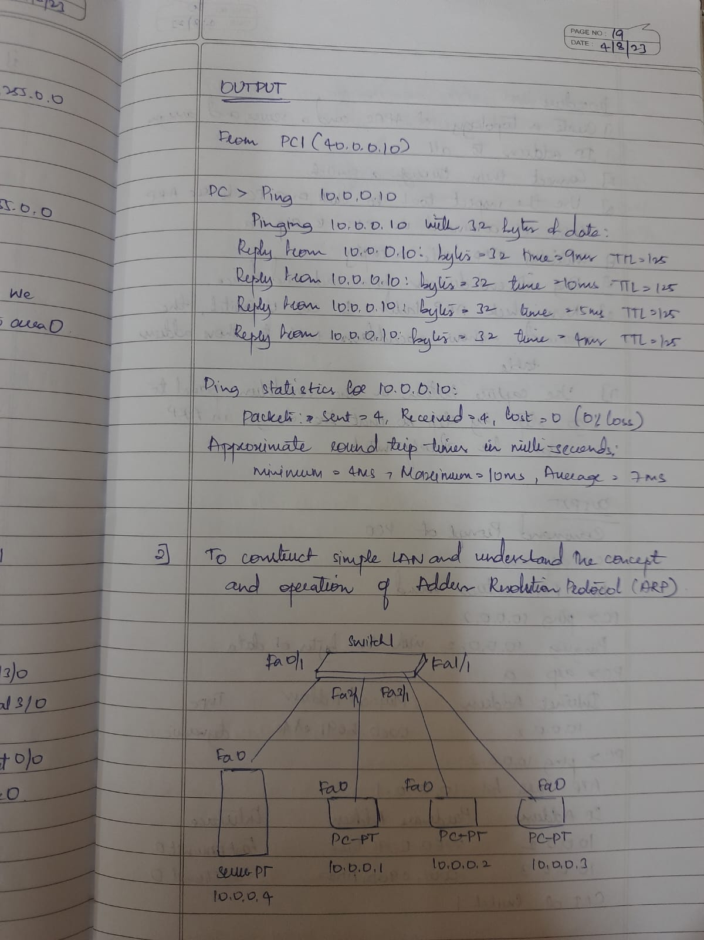

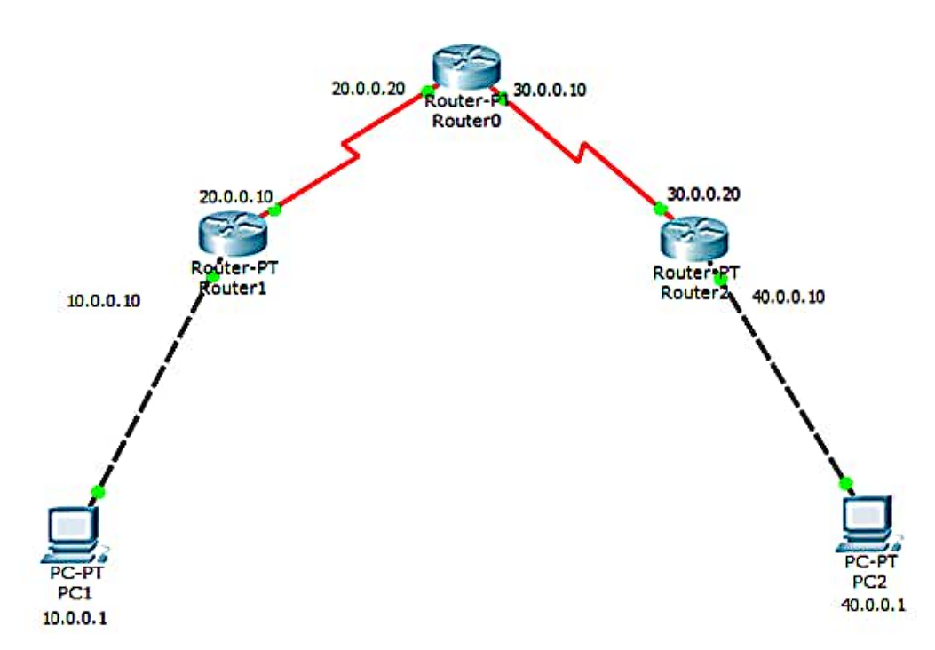**TOPOLOGY**

**OUTPUT**

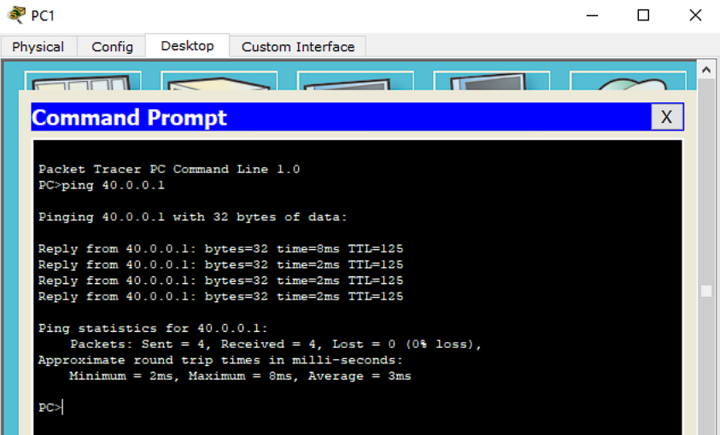

**PROGRAM -7**

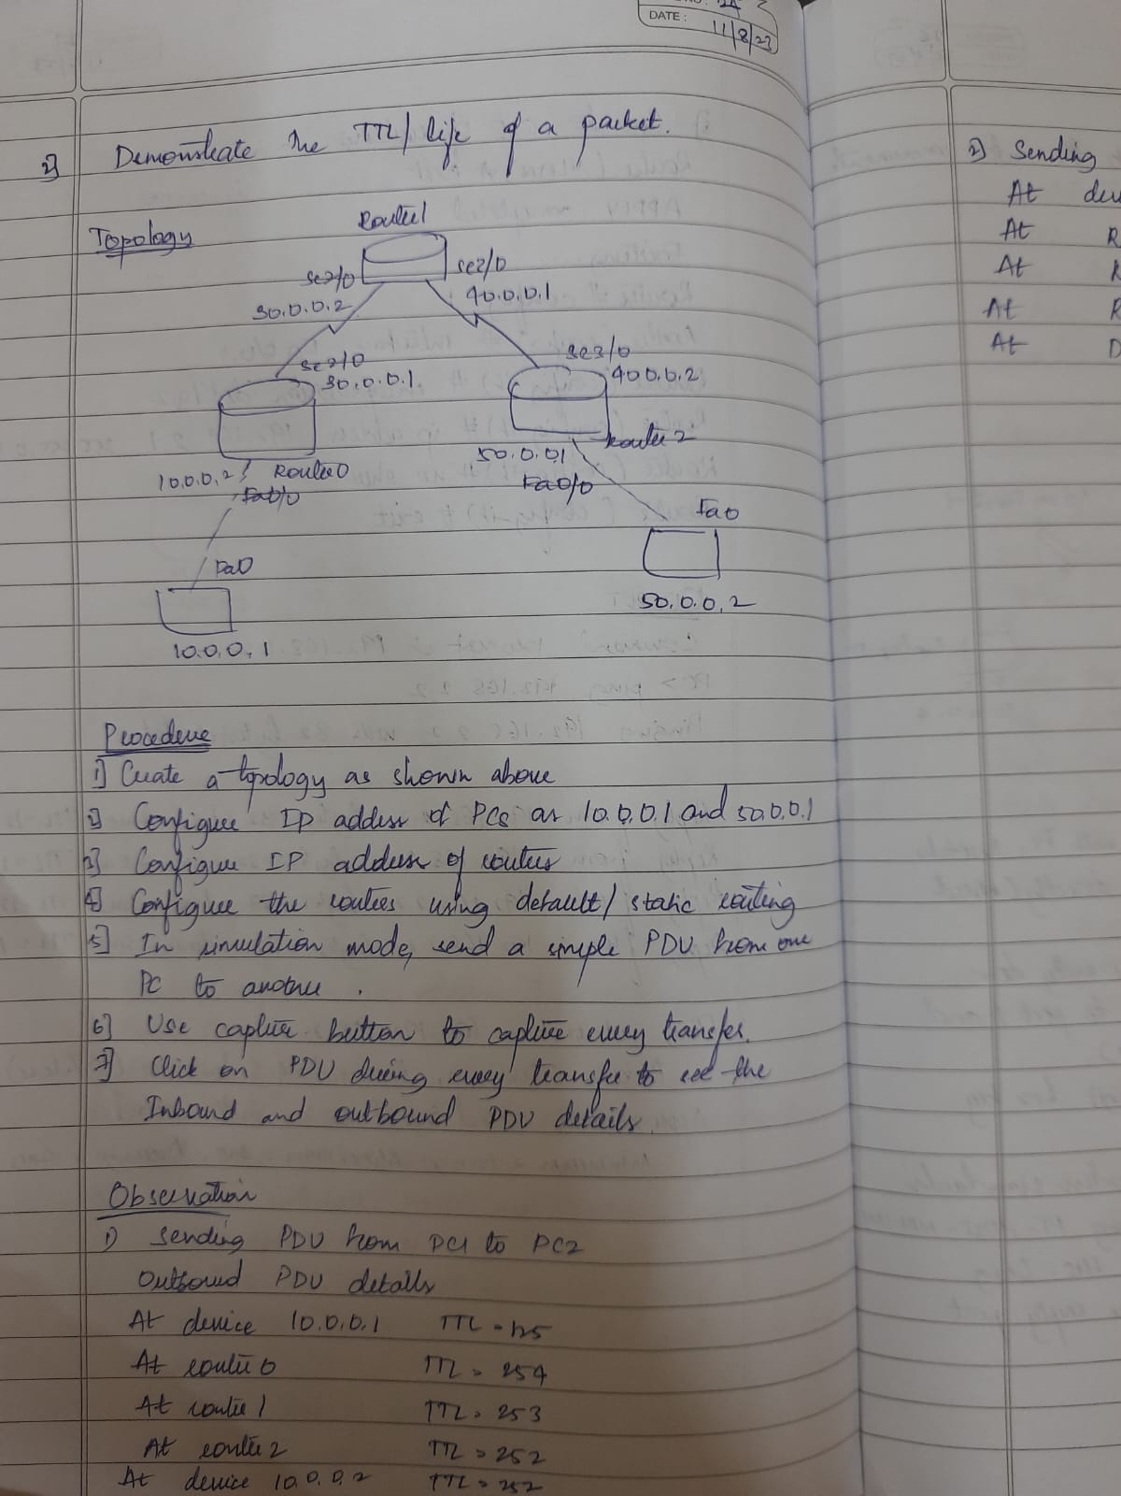Demonstrate the TTL/ Life of a Packet

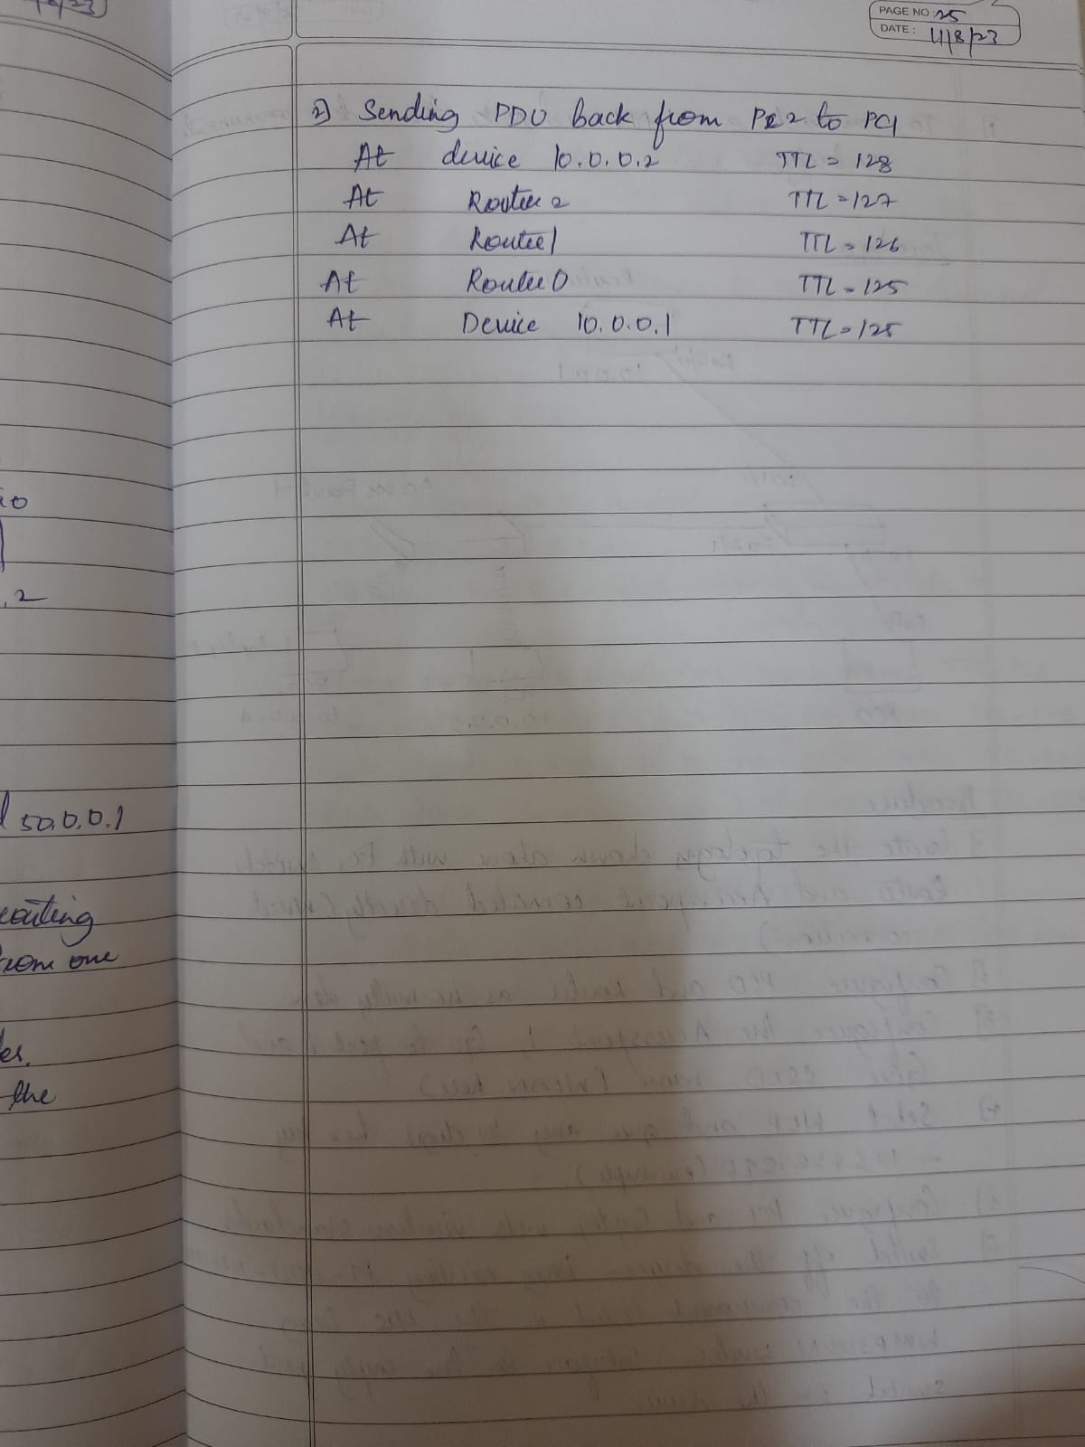

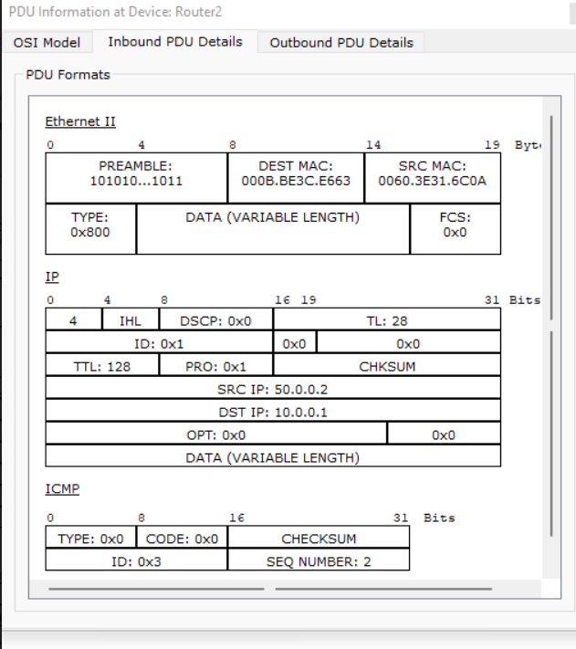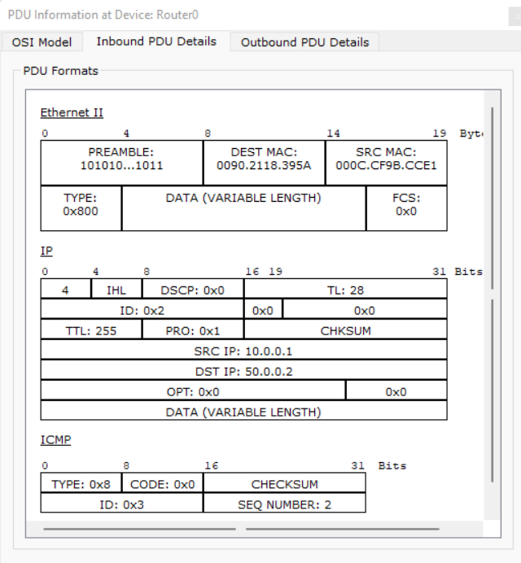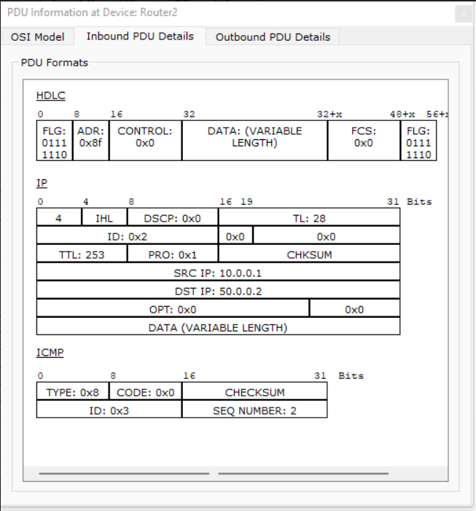

**PROGRAM -8**

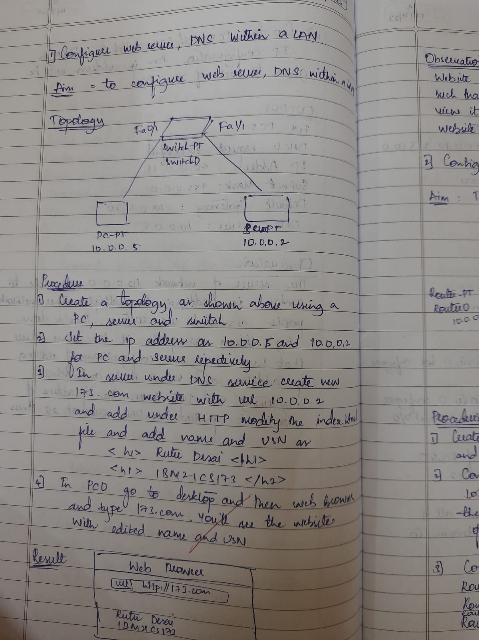**Configure Web Server, DNS within a LAN.**



**TOPOLOGY**

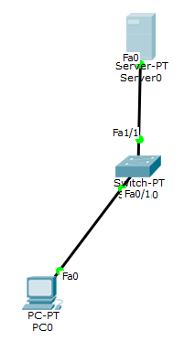

**CONFIGURATION**

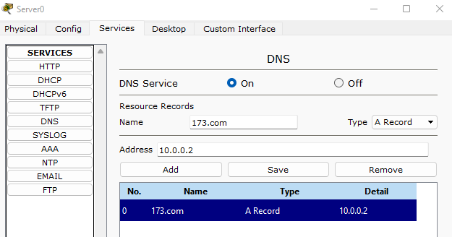

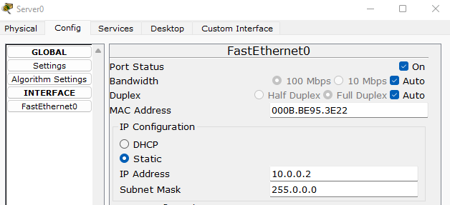

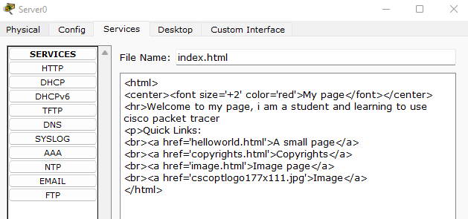

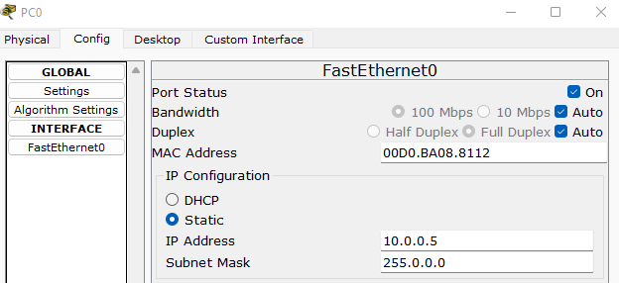

**OUTPUT**

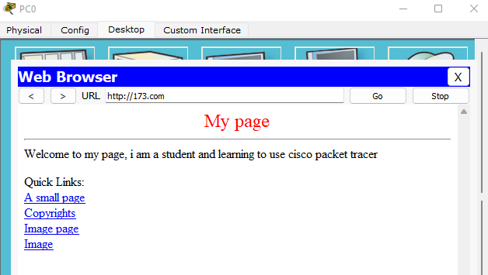

**PROGRAM -9**

To construct simple LAN and understand the concept and operation of Address Resolution Protocol (ARP)

**TOPOLOGY**

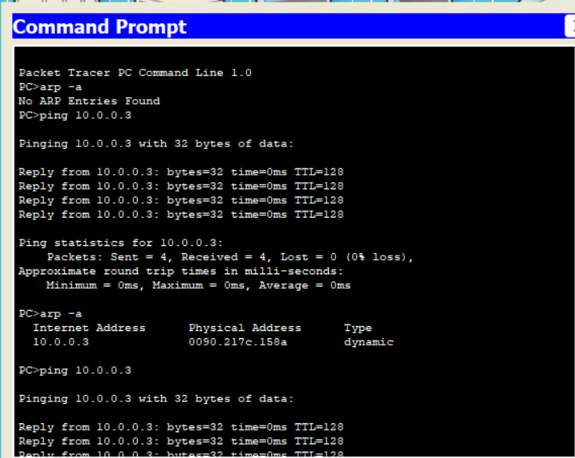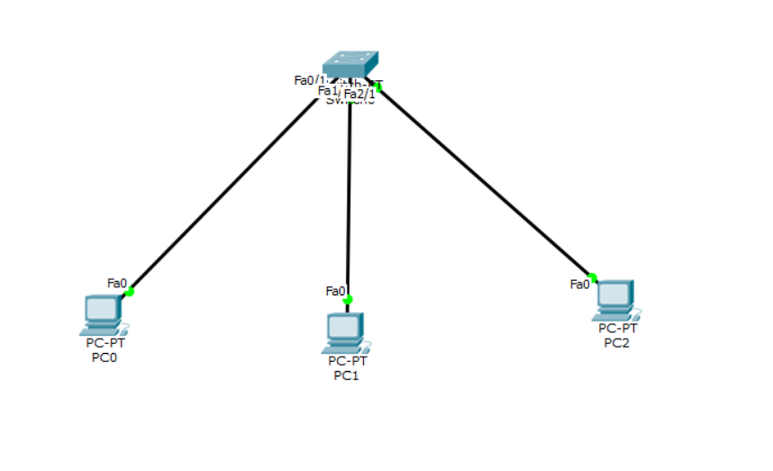**OUTPUT**

**PROGRAM -10**

To understand the operation of TELNET by accessing the router in server room from a PC in IT office.

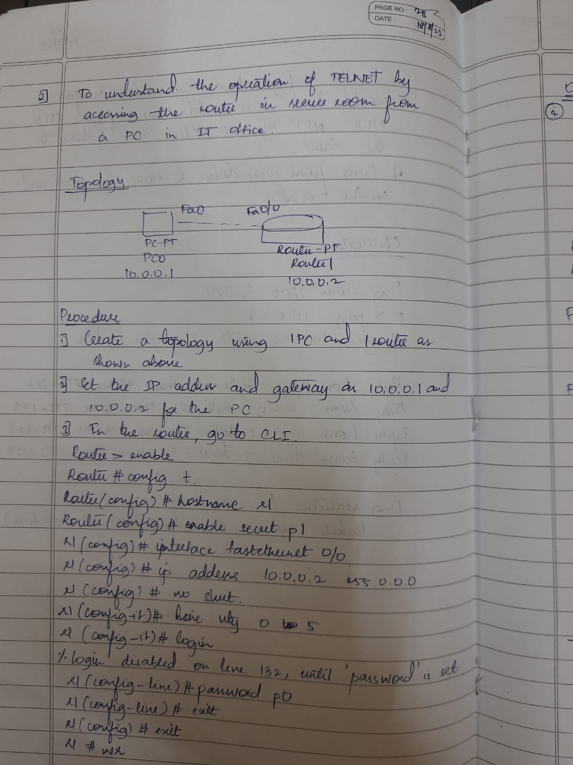

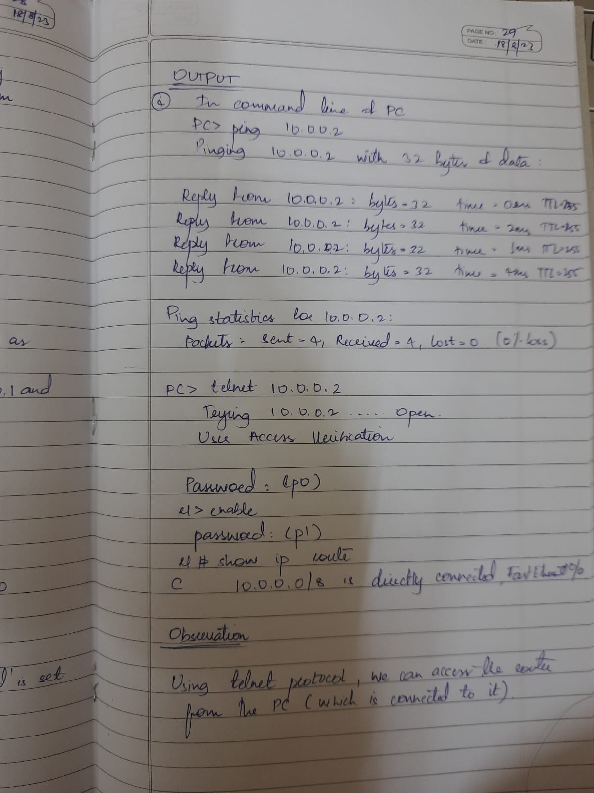

**TOPOLOGY**

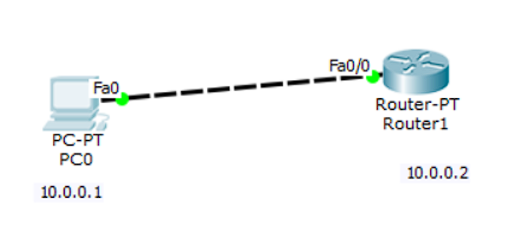

**OUTPUT**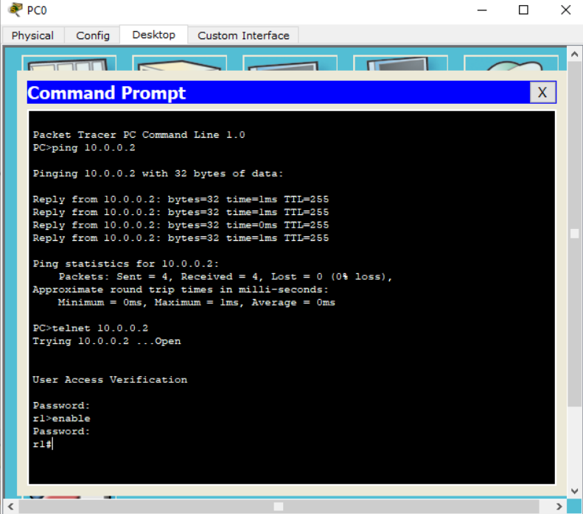

**PROGRAM -11**

To construct a VLAN and make the PC’s communicate among a VLAN

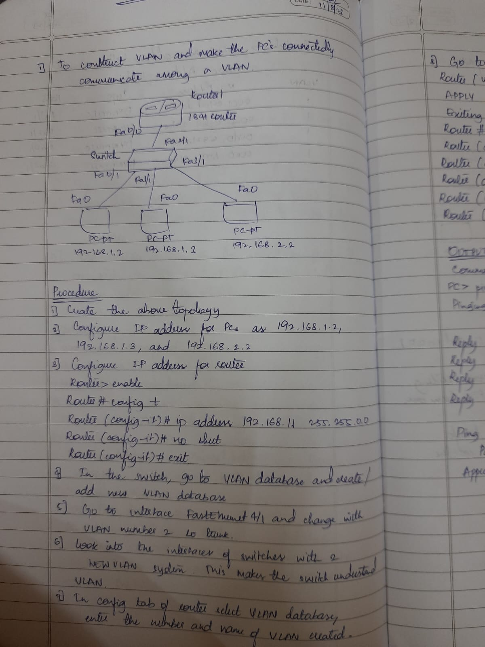

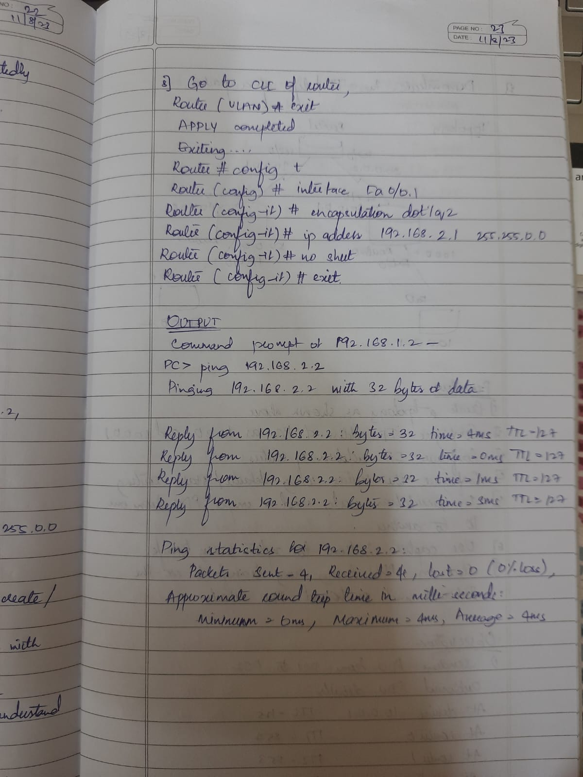

**TOPOLOGY**

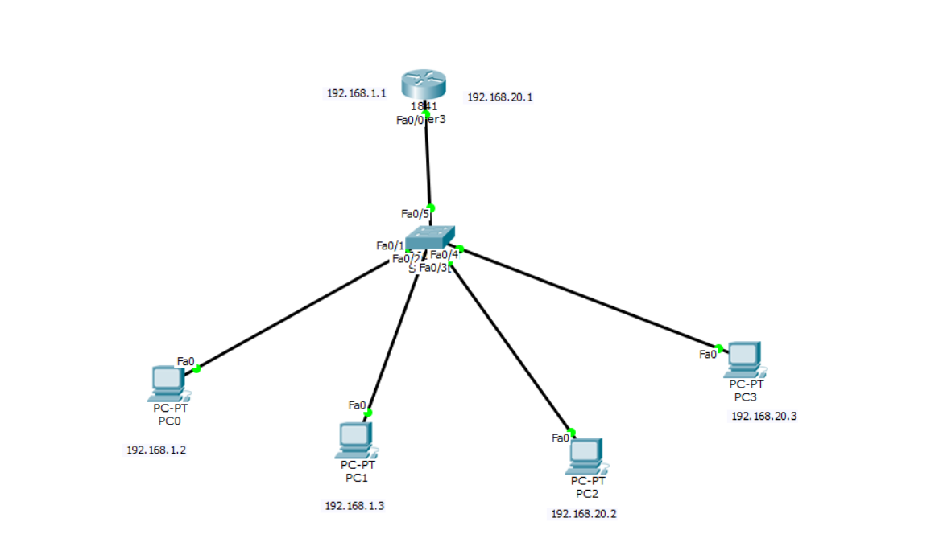

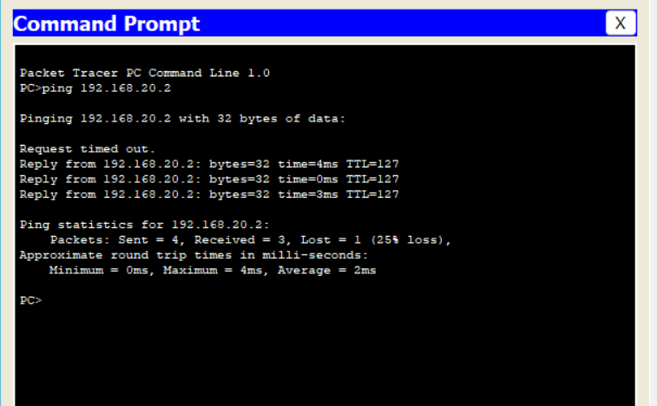

**PROGRAM 12**

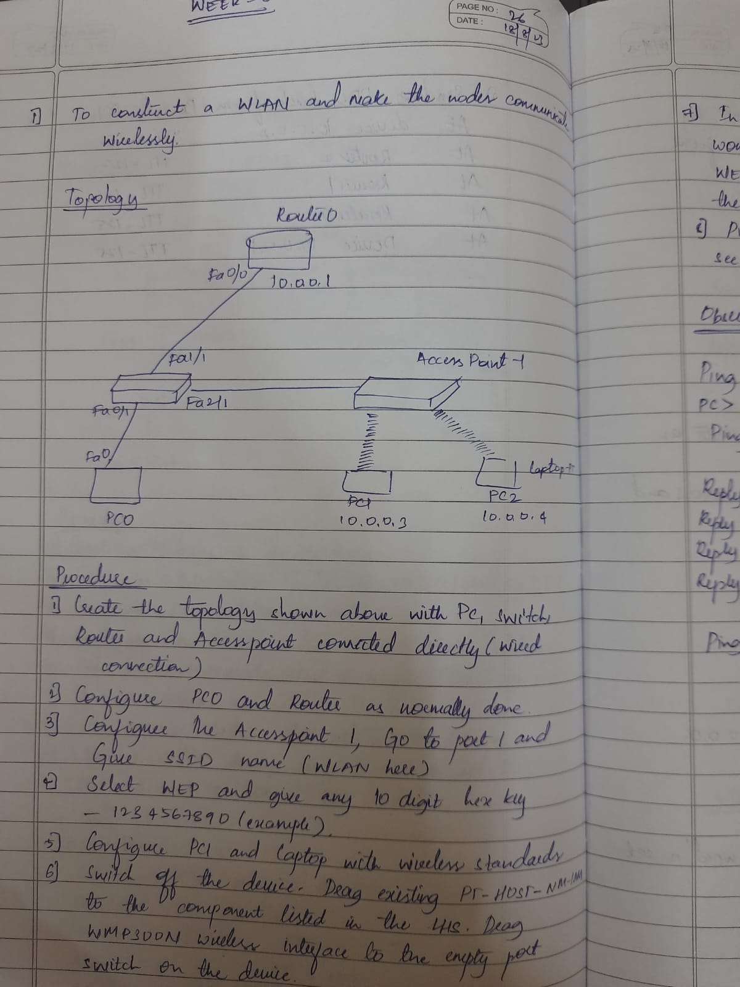**To construct a WLAN and make the nodes communicate wirelessly**

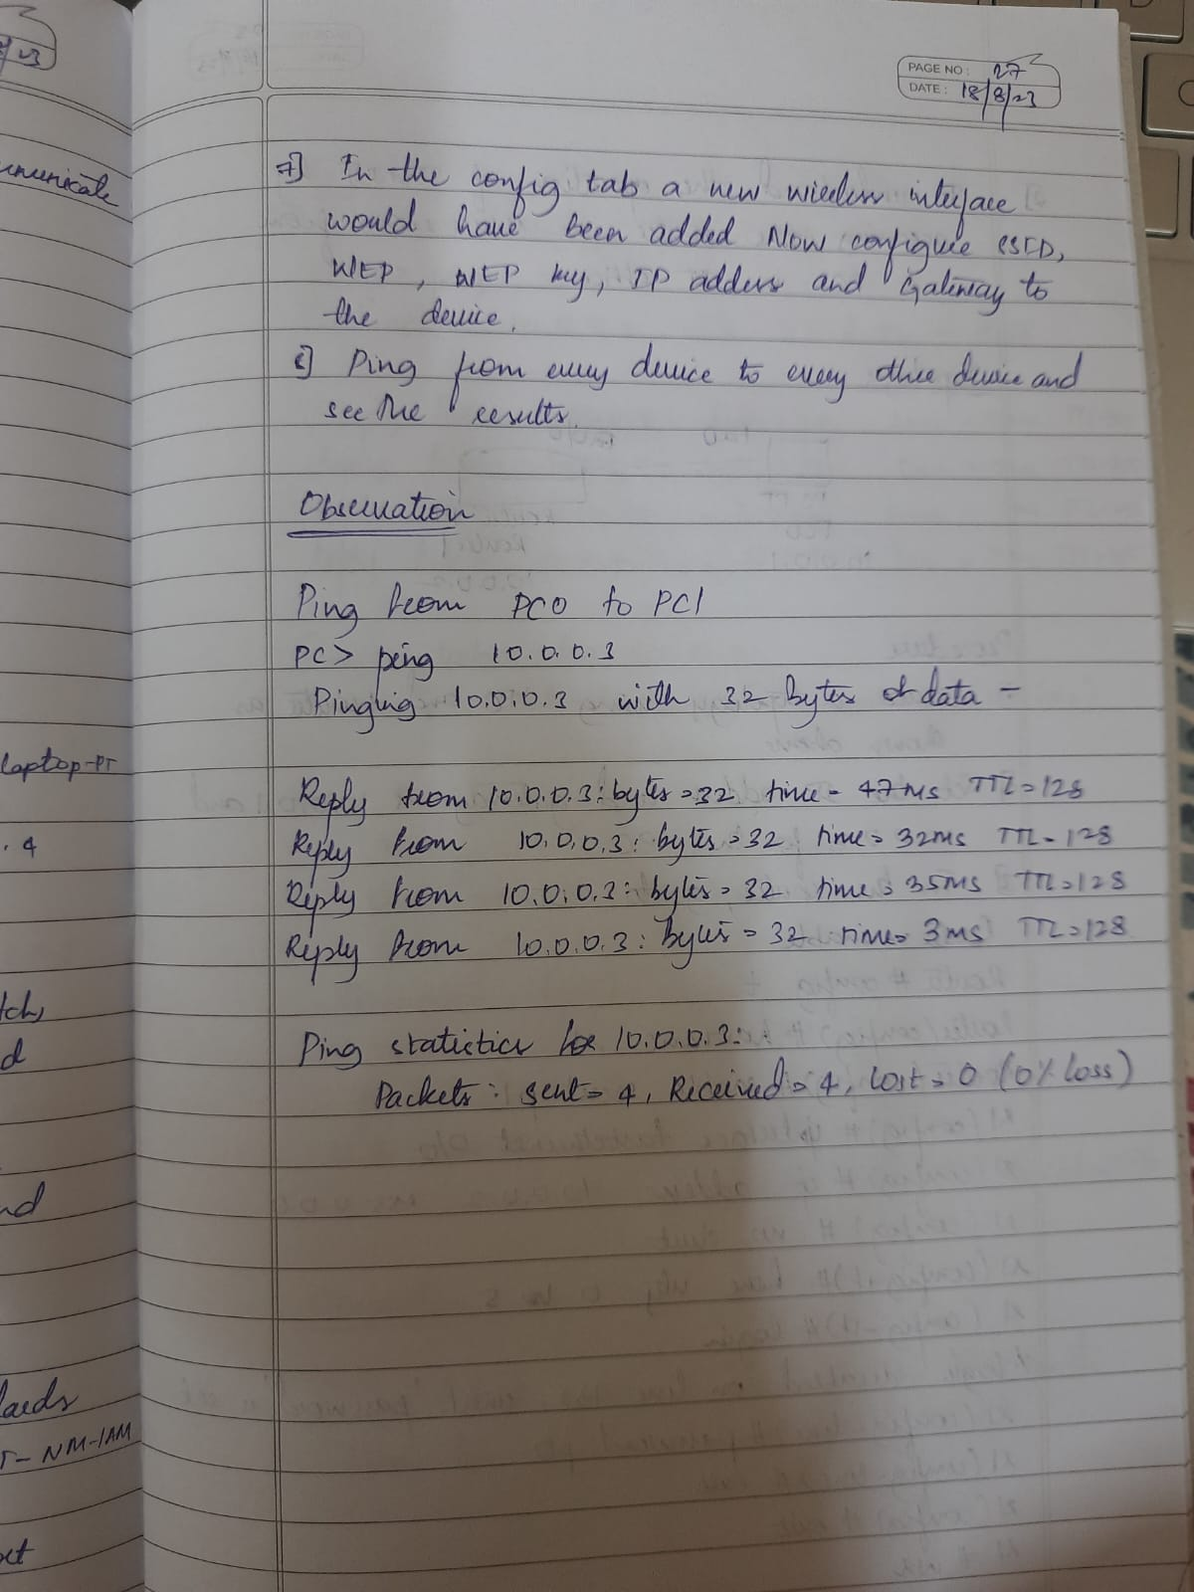

**TOPOLOGY**

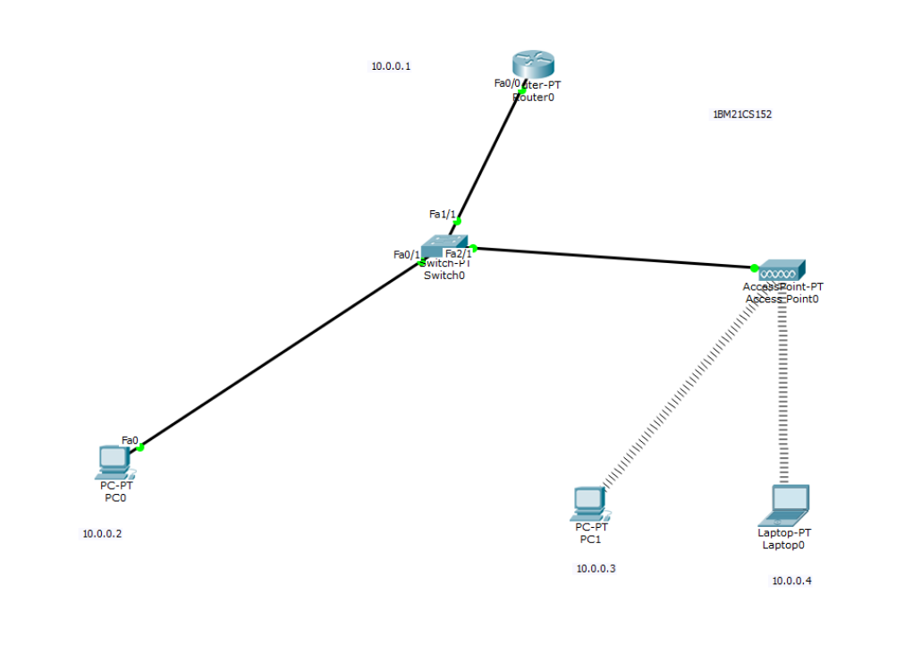

**OUTPUT**

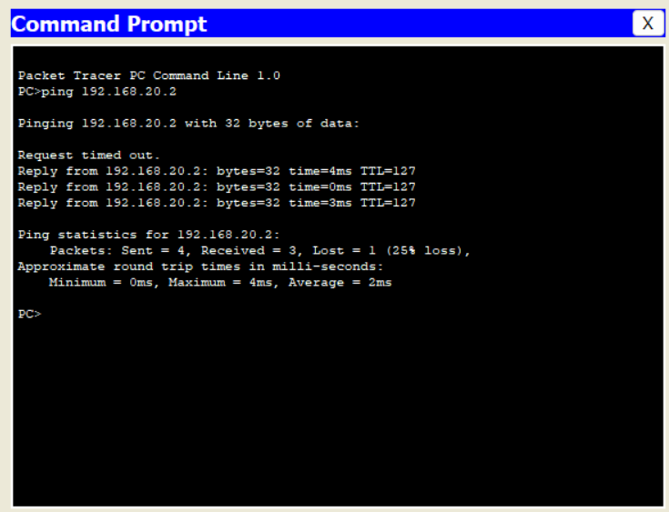

**CYCLE - 2**

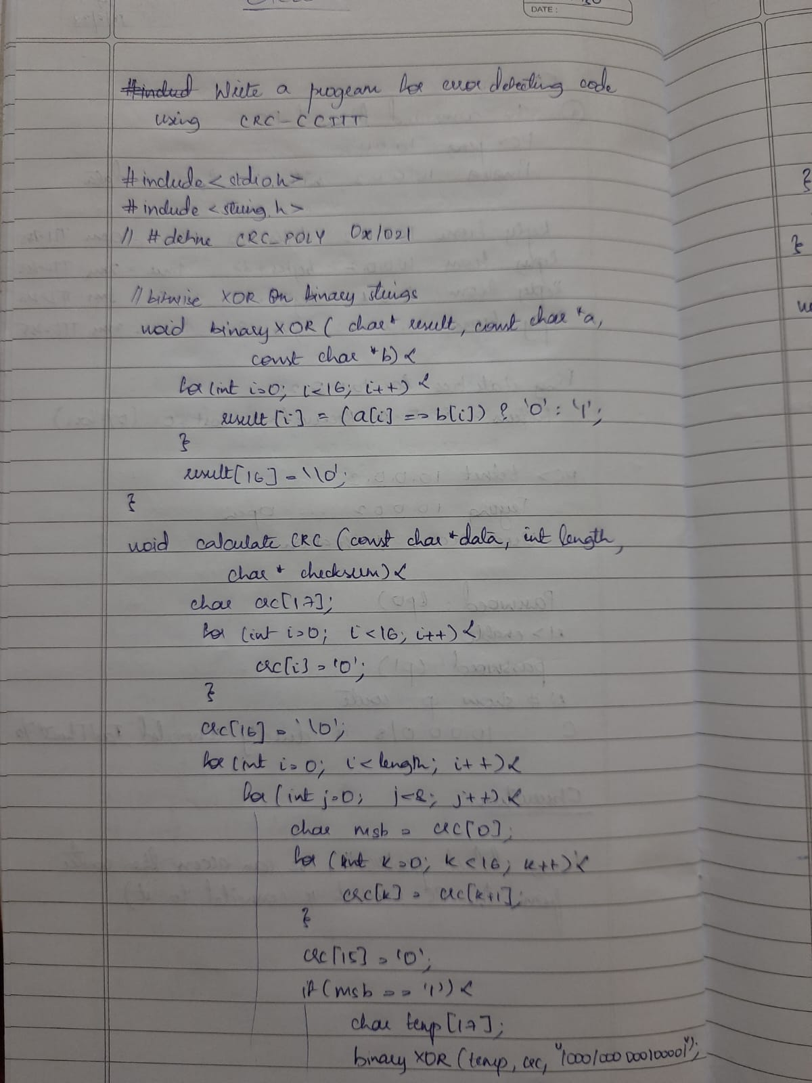***Write a program for error detecting code using CRC_CCITT(16 bits)***

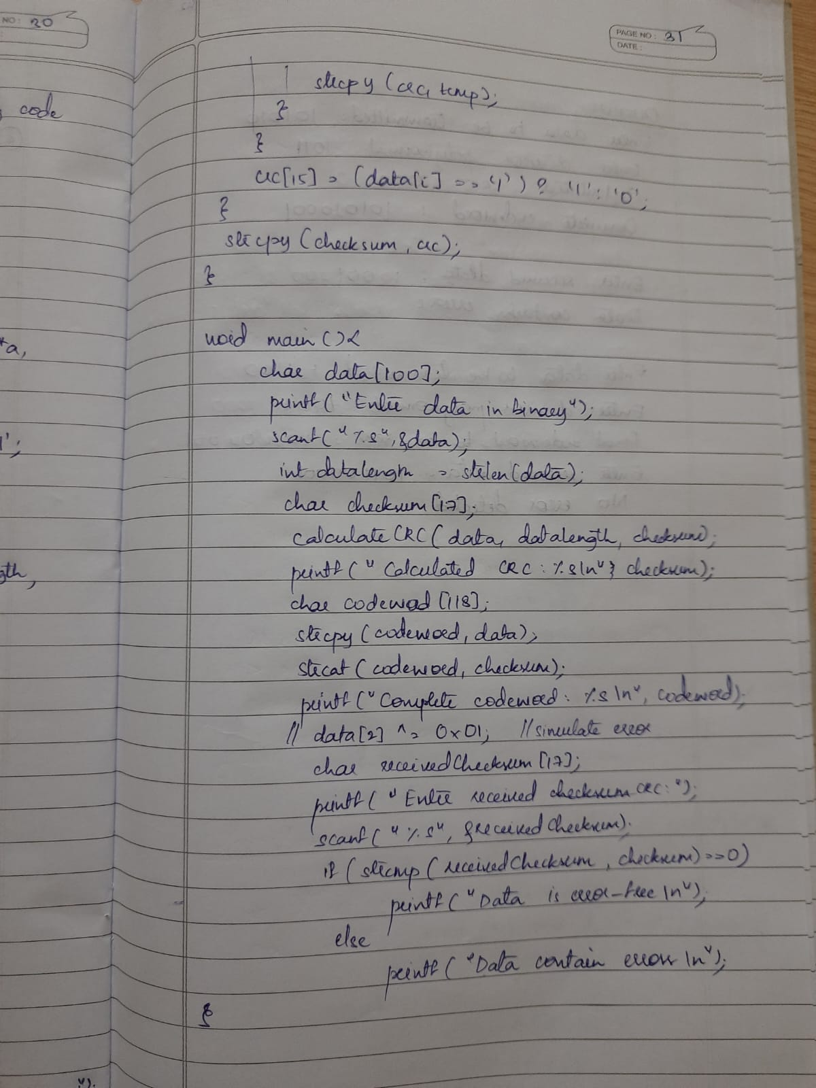

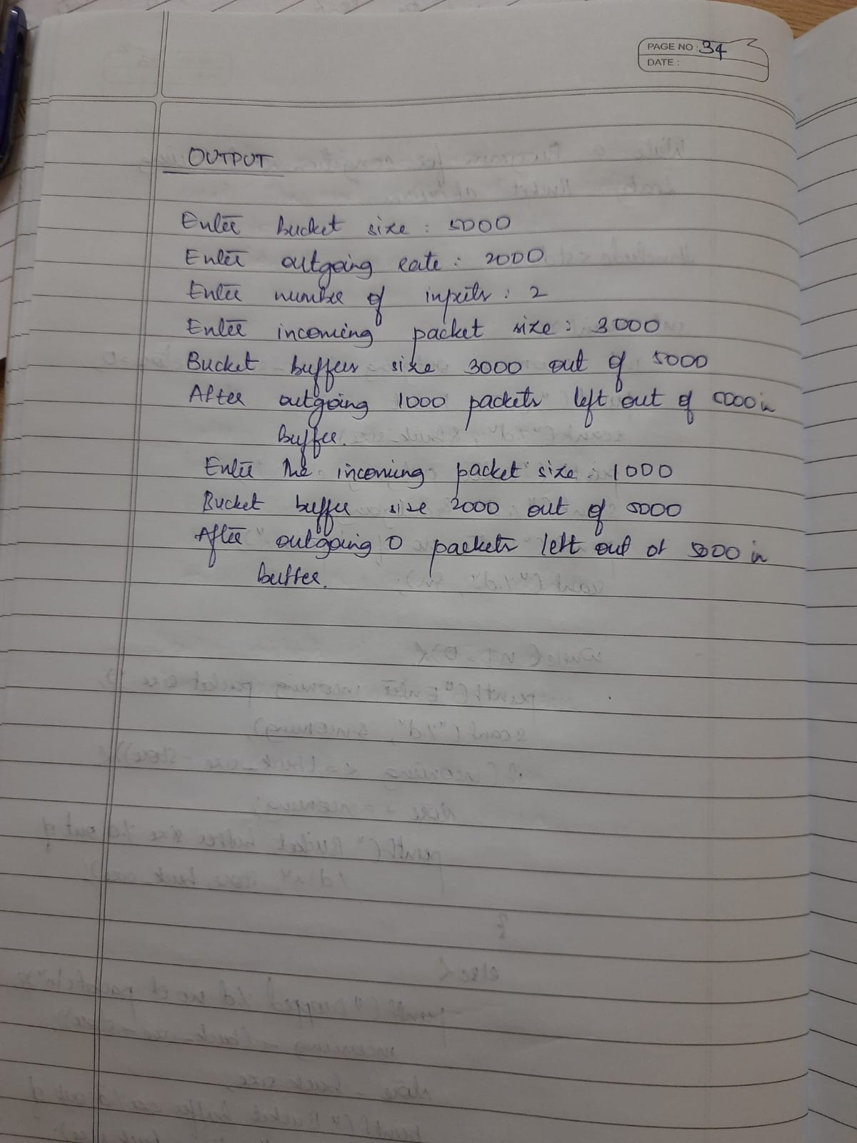

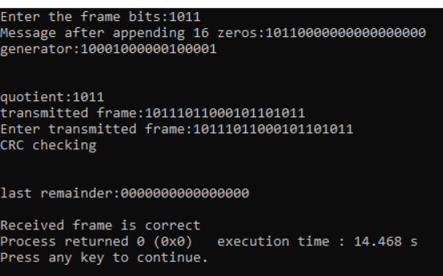

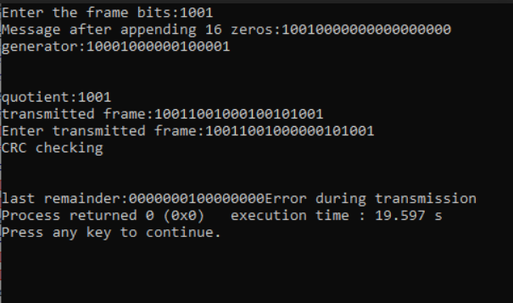

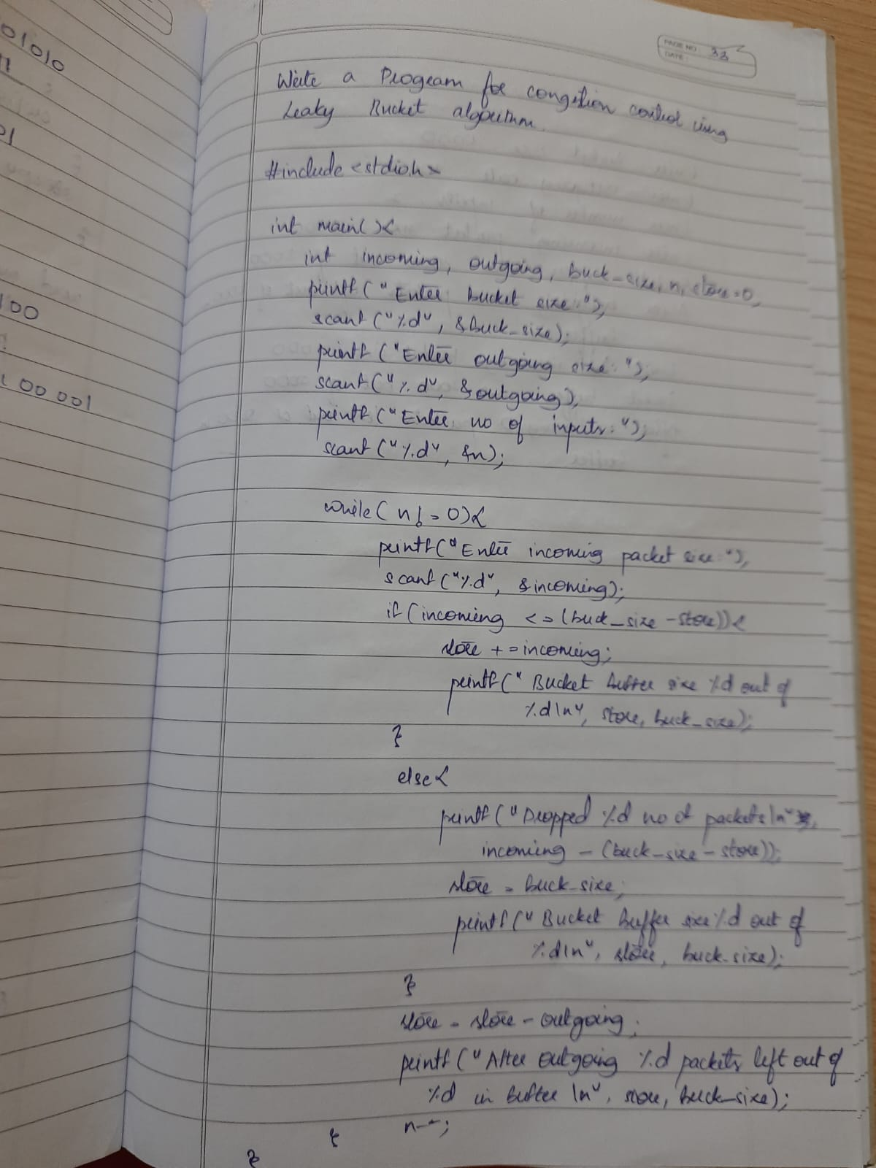**Write a program for congestion control using leaky bucket algorithm**

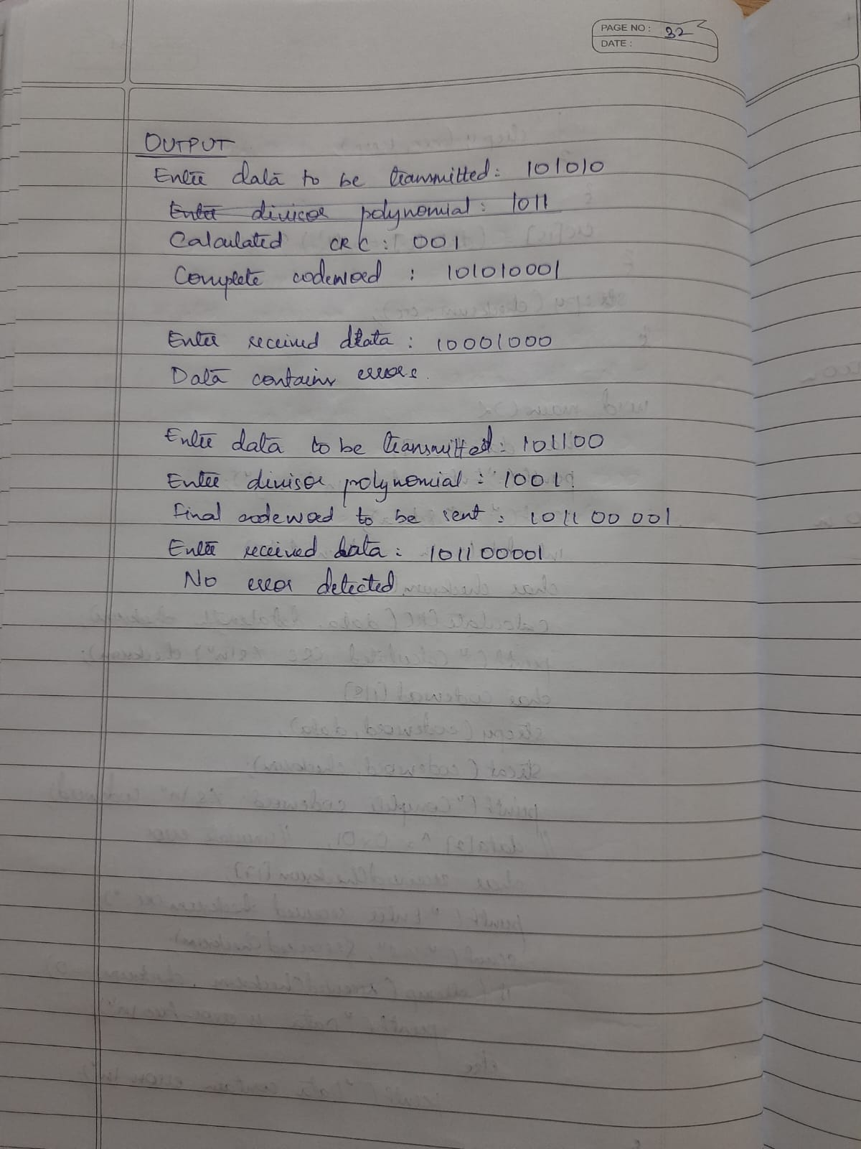

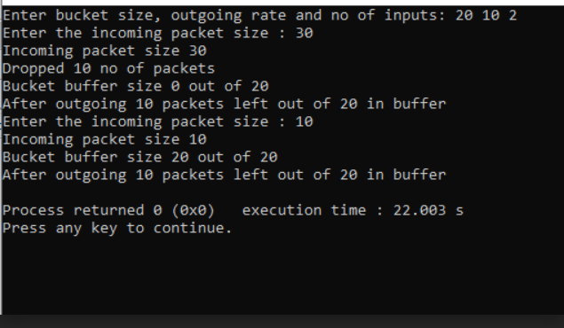

**Using TCP/IP sockets, write a client-server program to make client sending the file name and the server to send back the contents of the requested file if present.**

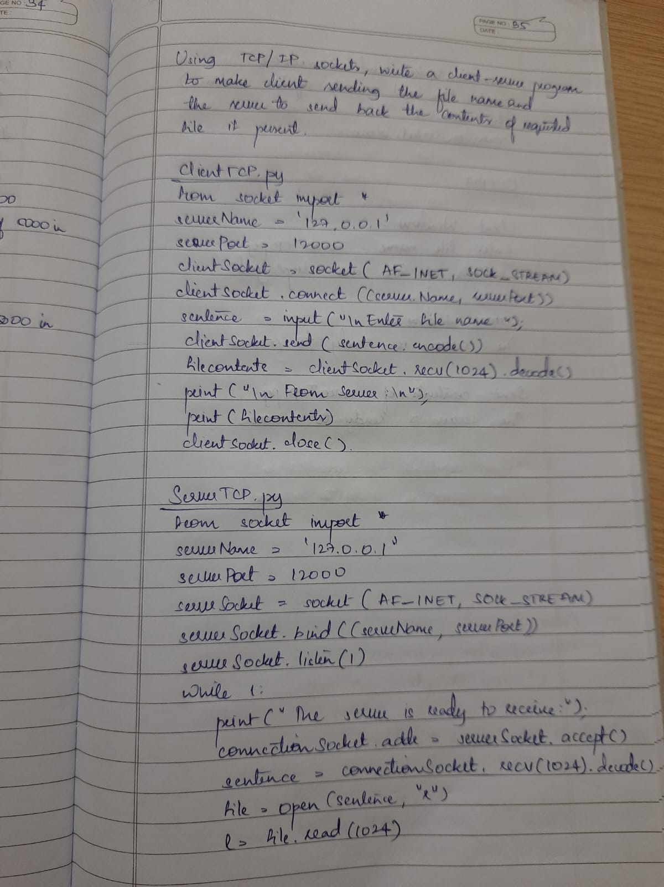

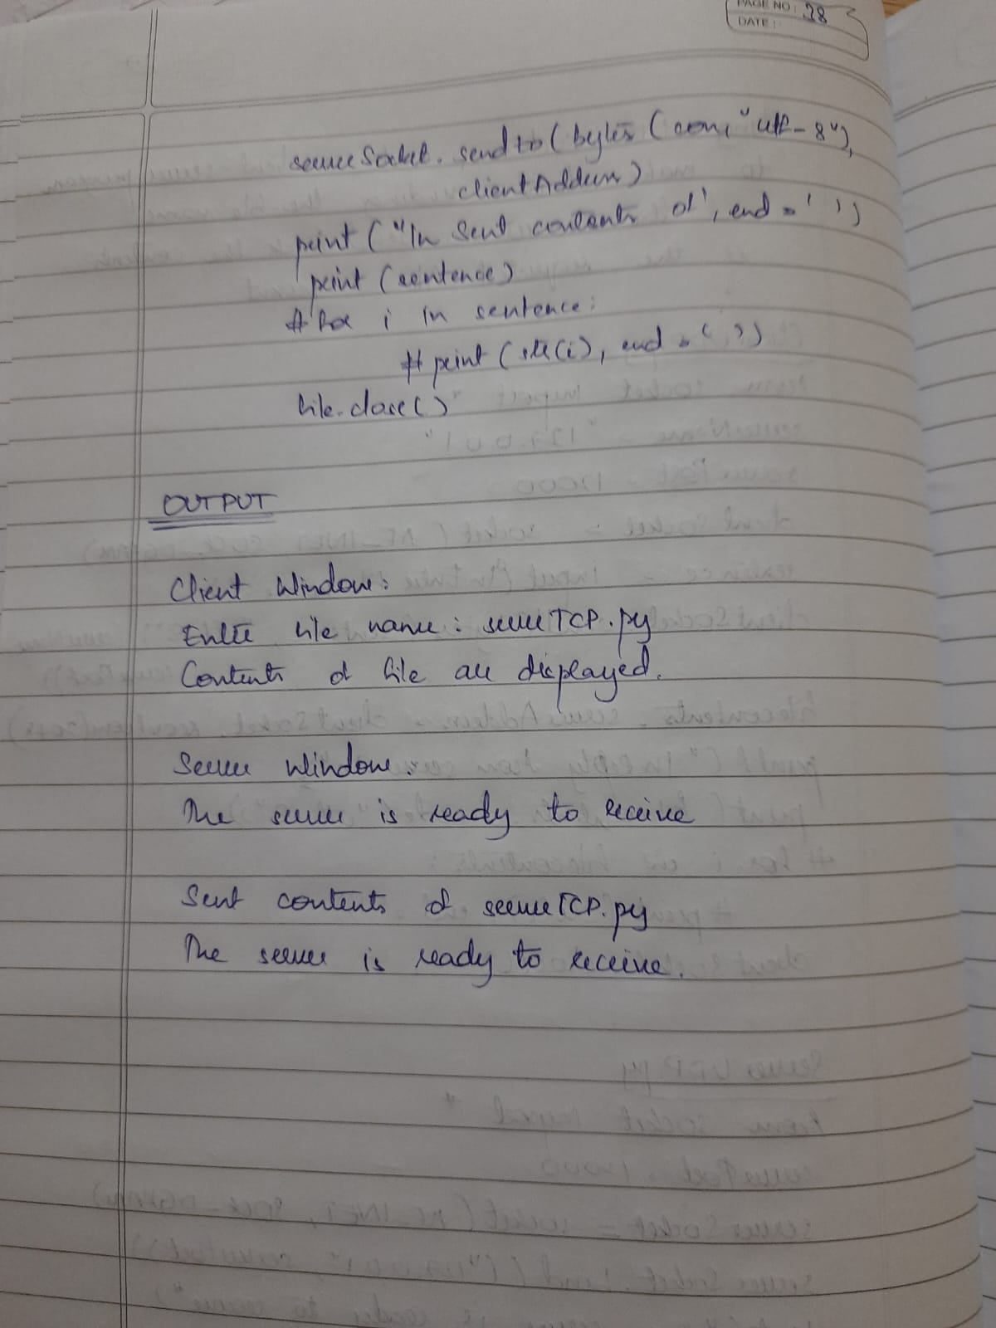

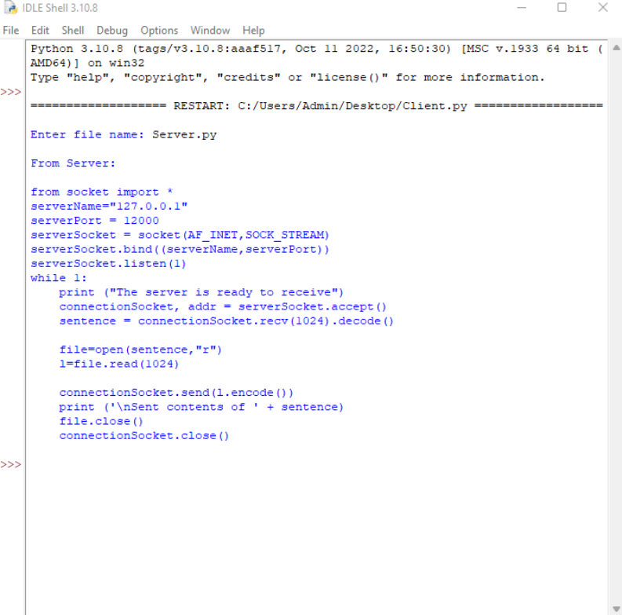

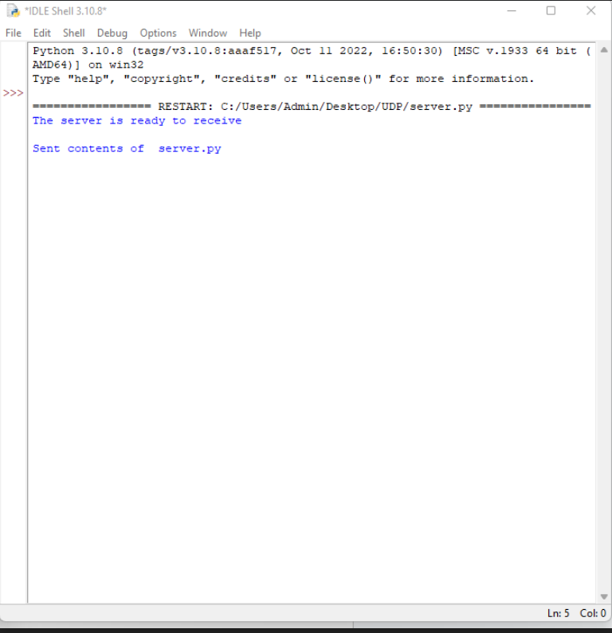

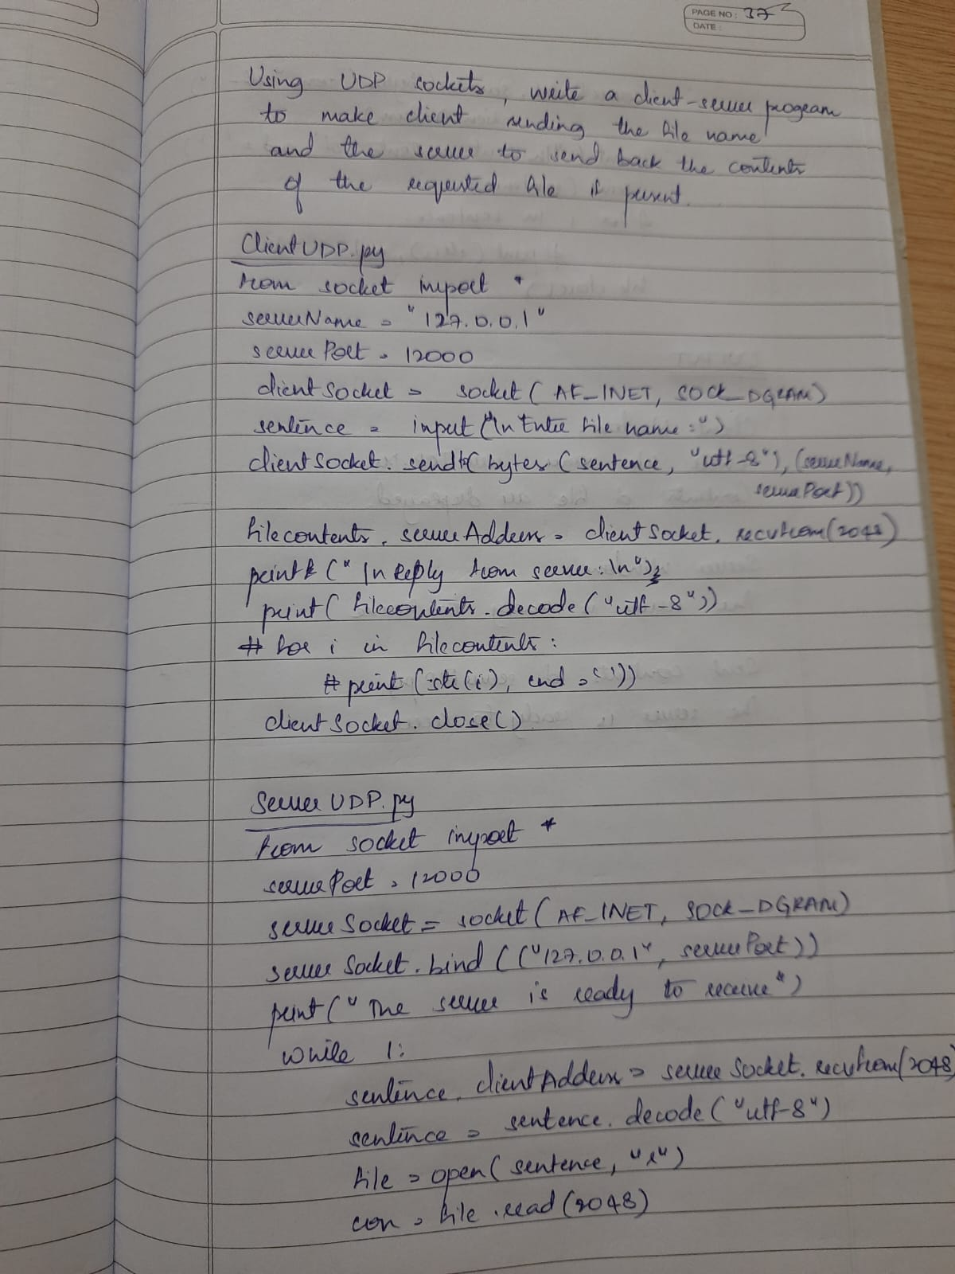**Using UDP sockets, write a client-server program to make client sending the file name and the server to send back the contents of the requested file if present.**

